*TIME SERIES MODELLING PROJECT*

*BUSINESS REPORT*

***Report by:***

Tushar Babbar

PGPDSBA Online

DSBA Dec20 Group 5

*Table of Contents*

**Problem Statement .................................................................................................................................................... 4**

1) Read and plot Time Series Data ..................................................................................................................................................... 4

2) Perform EDA and Decomposition. ................................................................................................................................................ 7

3) Splitting the Data into Training and Testing.......................................................................................................................... 26

4) Build various exponential smoothing models.Check RMSE!............................................................................................... 28

5) Check for Stationarity at alpha = 0.05........................................................................................................................................ 50

6) Build an automated version of the ARIMA/SARIMA .............................................................................................................. 52

7) Build ARIMA/SARIMA models based on the cut-off points of ACF and PACF ………………………………………….. 62

8) Create a data frame of all the models along their parameters and RMSE .................................................................... 81

9) Build the most optimum model on complete dataset………………………………………………………………. 83

10) Report and Suggestions……………………………………………………………………………………………… 86

*Table of Figures*

Figure 1(a) Sparkling Time Series ............................................................................................................................................ 5

Figure 1(b) Rose Time Series................................................................................................................................................... 7

Figure 2(a) Sparkling Yearly Boxplot ....................................................................................................................................... 8

Figure 2(b) Sparkling Monthly Boxplot.................................................... …………………………………………………………………………… 9

Figure 2(c) Rose Yearly Boxplot............................................................................................................................................... 9

Figure 2(d) Rose Monthly Boxplot........................................................................................................................................... 10

Figure 2.2(a) Sparkling time series monthplot.................................................................................................................... 10

Figure 2.2(b) Rose time series monthplot............................................................................................................................ 11

Figure 2.2(c) Graph of monthly Sparkling Sales across years........................................................................................... 12

Figure 2.2(d) Graph of monthly Sparkling Sales across years........................................................................................... 13

Figure 2.3(a) Empirical Cumulative Distribution Sparkling................................................................................................. 13

Figure 2.3(b) Empirical Cumulative Distribution Rose........................................................................................................ 14

Figure 2.4(a) Average Sales and Percentage Change Plot Sparkling ........................................................................................ 14

Figure 2.4(b) Average Sales and Percentage Change Plot Rose............................................................................................... 15

Figure 2.5(a) Additive Decomposition - Sparkling ................................................................................................................... 15

Figure 2.5(b) Multiplicative Decomposition - Sparkling........................................................................................................... 17

Figure 2.5(c) Stationary Check plot Sparkling before Differencing .......................................................................................... 18

Figure 2.5(d) Stationary Check plot Sparkling after Differencing............................................................................................. 19

Figure 2.6(a) Additive Decomposition - Rose........................................................................................................................... 19

Figure 2.6(b) Multiplicative Decomposition - Rose.................................................................................................................. 21

Figure 2.6(c) Stationary Check plot Rose before Differencing ................................................................................................. 22

Figure 2.6(d) Stationary Check plot Rose after Differencing.................................................................................................... 23

Figure 2.7(a) ACF plot - Sparkling ............................................................................................................................................ 24

Figure 2.7(b) PACF plot - Sparkling......................................................................………………………………………………………………… 24

Figure 2.7(c) ACF plot - Rose.................................................................................................................................................... 25

Figure 2.7(d) PACF plot - Rose................................................................................................................................................. 26

Figure 3(a) Train/Test Split Plot - Sparkling ............................................................................................................................ 27

Figure 3(b) Train/Test Split Plot - Rose.................................................................................................................................... 28

Figure 4.1(a) Sparkling Linear Regression Model............................................................................................................... 29

Figure 4.1(b) Rose Linear Regression Model....................................................................................................................... 30

Figure 4.2(a) Sparkling Naive Model..................................................................................................................................... 32

Figure 4.2(b) Rose Naive Model............................................................................................................................................. 33

Figure 4.3(a) Sparkling Simple Average Model.................................................................................................................... 34

Figure 4.3(b) Rose Simple Average Model........................................................................................................................... 34

Figure 4.4(a) Sparkling Trailing Moving Average Model..................................................................................................... 36

Figure 4.4(b) Sparkling Moving Average Model Train/Test............................................................................................... 37

Figure 4.4(c) Rose Trailing Moving Average Model............................................................................................................ 38

Figure 4.4(d) Rose Moving Average Model Train/Test....................................................................................................... 39

Figure 4.4(e) Sparkling Model Comparison.......................................................................................................................... 40

Figure 4.4(f) Rose Model Comparison.................................................................................................................................. 40

Figure 4.5(a) Simple Exponential Smoothing Sparkling Autofit Model.................................................................................... 41

Figure 4.5(b) Simple Exponential Smoothing Rose Autofit Model........................................................................................... 42

Figure 4.5(c) Simple Exponential Smoothing Sparkling Bestfit Model..................................................................................... 43

Figure 4.5(d) Simple Exponential Smoothing Rose Bestfit Model............................................................................................ 44

Figure 4.6(a) Double Exponential Smoothing (Holt’s Model) Sparkling Bestfit Model............................................................ 45

Figure 4.6(b) Double Exponential Smoothing (Holt’s Model) Rose Bestfit Model................................................................... 45

Figure 4.7(a) Triple Exponential Smoothing (Holt Winter’s Model) Sparkling Autofit Model................................................. 46

Figure 4.7(b) Triple Exponential Smoothing (Holt Winter’s Model) Rose Autofit Model........................................................ 47

Figure 4.7(c) Triple Exponential Smoothing (Holt Winter’s Model) Sparkling Bestfit Model.................................................. 48

Figure 4.7(d) Triple Exponential Smoothing (Holt Winter’s Model) Rose Bestfit Model......................................................... 49

Figure 5.1(a) Stationary Check plot Sparkling before Differencing Train Set .......................................................................... 50

Figure 5.1(b) Stationary Check plot Sparkling after Differencing Train Set.............................................................................. 50

Figure 5.2(a) Stationary Check plot Rose before Differencing Train Set ................................................................................. 51

Figure 5.2(b) Stationary Check plot Rose after Differencing Train Set.................................................................................... 52

Figure 6.1(a) Sparkling SARIMA ACF Seasonality 6 .................................................................................................................. 55

Figure 6.1(b) Sparkling SARIMA Diagnostic Plot Seasonality 6................................................................................................. 56

Figure 6.2(a) Rose SARIMA ACF Seasonality 6.......................................................................................................................... 57

Figure 6.2(b) Rose SARIMA Diagnostic Plot Seasonality 6…………………………………………………………………………………………………… 58

Figure 6.3(a) Sparkling SARIMA Diagnostic Plot Seasonality 12............................................................................................... 60

Figure 6.3(b) Rose SARIMA Diagnostic Plot Seasonality 12...................................................................................................... 61

Figure 7.1(a) Sparkling ARIMA Differenced ACF/PACF............................................................................................................. 63

Figure 7.1(b) Rose ARIMA Differenced ACF/PACF.................................................................................................................... 64

Figure 7.2(a) Sparkling SARIMA Differenced ACF/PACF........................................................................................................... 66

Figure 7.2(b) Sparkling Test Time Series Plot .......................................................................................................................... 66

Figure 7.2(c) Sparkling Difference Test Time Series Plot Seasonality = 6................................................................................. 66

Figure 7.2(d) Sparkling Test Stationarity Check Plot................................................................................................................ 67

Figure 7.2(e) Sparkling SARIMA Modified ACF/PACF............................................................................................................... 68

Figure 7.2(f) Sparkling SARIMA Diagnostic Plot Seasonality = 6............................................................................................... 69

Figure 7.3(a) Sparkling Difference Test Time Series Plot Seasonality = 12............................................................................... 70

Figure 7.3(b) Sparkling Test Stationarity Check Plot................................................................................................................ 70

Figure 7.3(c) Sparkling SARIMA Modified ACF/PACF.............................................................................................................. 71

Figure 7.3(d) Sparkling SARIMA Diagnostic Plot Seasonality = 12........................................................................................... 72

Figure 7.4(a) Rose SARIMA Differenced ACF/PACF.................................................................................................................. 73

Figure 7.4(b) Rose Test Time Series Plot ................................................................................................................................. 74

Figure 7.5(a) Rose Difference Test Time Series Plot Seasonality = 6....................................................................................... 74

Figure 7.5(b) Rose Test Stationarity Check Plot....................................................................................................................... 75

Figure 7.5(c) Rose SARIMA Modified ACF/PACF..................................................................................................................... 76

Figure 7.5(d) Rose SARIMA Diagnostic Plot Seasonality = 6.................................................................................................... 77

Figure 7.6(a) Rose Difference Test Time Series Plot Seasonality = 12..................................................................................... 78

Figure 7.6(b) Rose Test Stationarity Check Plot...................................................................................................................... 78

Figure 7.6(c) Rose SARIMA Modified ACF/PACF..................................................................................................................... 79

Figure 7.6(d) Rose SARIMA Diagnostic Plot Seasonality = 12.................................................................................................. 80

Figure 9(a) Sparkling Optimum Model Forecast................................................................................................................. 84

Figure 9(b) Rose Optimum Model Forecast......................................................................................................................... 86

# Problem 1: Linear Regression

## For this particular assignment, the data of different types of wine sales in the 20th century is to be analysed. Both of these data are from the same company but of different wines. As an analyst in the ABC Estate Wines, you are tasked to analyse and forecast Wine Sales in the 20th century.

### Data Dictionary:

|  |  |
| --- | --- |
| ***Variable Name*** | ***Description*** |
| Sparkling | -- Sales dataset for Sparkling Dataset |
| Rose | -- Sales dataset for Rose Dataset |
| YearMonth | -- YearMonth indexes for sales . |

## Read the 'Sparkling' data as an appropriate Time Series data and plot the data.

### HEAD OF THE DATA

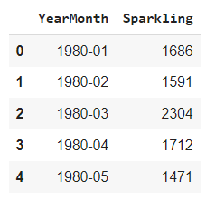

### TAIL OF THE DATA

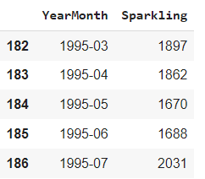

## Creating the Time Stamps and adding to the data frame to make it a Time Series Data

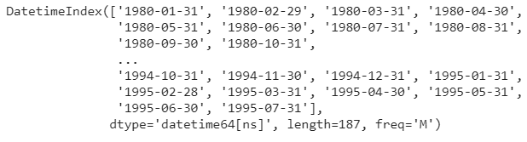

### Adding the time stamp to the data frame and setting it as index.

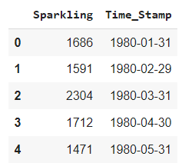

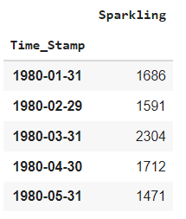

### Plot the Time Series to understand the behaviour of the data.

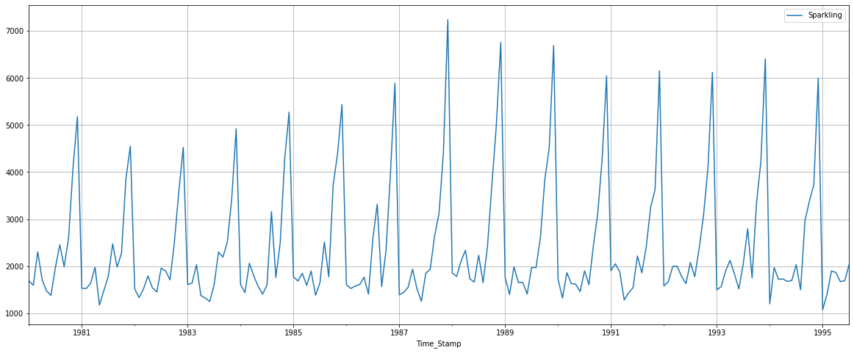

***Figure 1(a)***

* *As observed there is a slight trend in the data as well as seasonality.*

## 1A. Read the 'ROSE' data as an appropriate Time Series data and plot the data.

### HEAD OF THE DATA

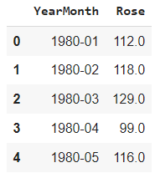

### TAIL OF THE DATA

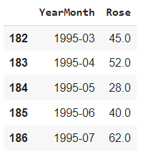

## 1A.1 Creating the Time Stamps and adding to the data frame to make it a Time Series Data



### 1A.2 Adding the time stamp to the data frame and setting it as index.

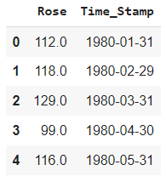

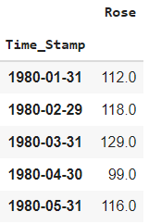

### 1A.3 Plot the Time Series to understand the behaviour of the data.

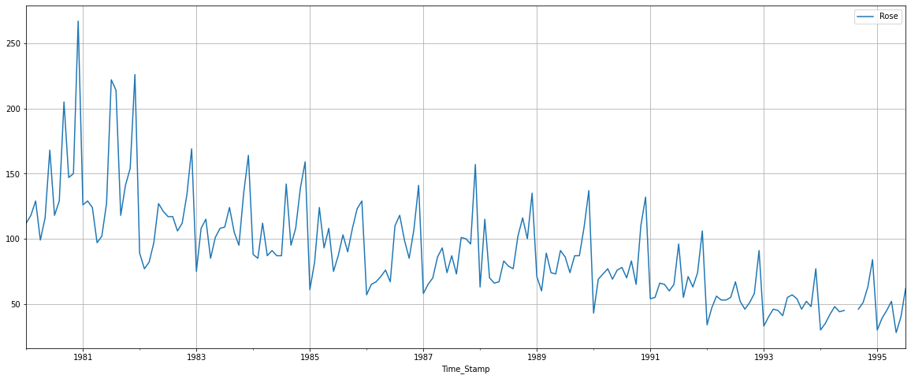

***Figure 1(b)***

* *As observed there is a slight trend in the data as well as seasonality.*

## Perform appropriate Exploratory Data Analysis to understand the data and also perform decomposition.

## Check the basic measures of descriptive statistics

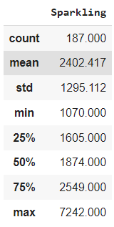

* **Sparkling has no null Values.**

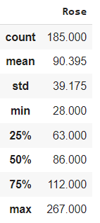

* **Rose has 2 null values, which will affect our model.**
* **To remove the null values, we have interpolated our dataset with method as ‘linear’.**

## 2.1 Plot a boxplot to understand the spread across different years and within different months across years.

## Sparkling Dataset

## Yearly Boxplot

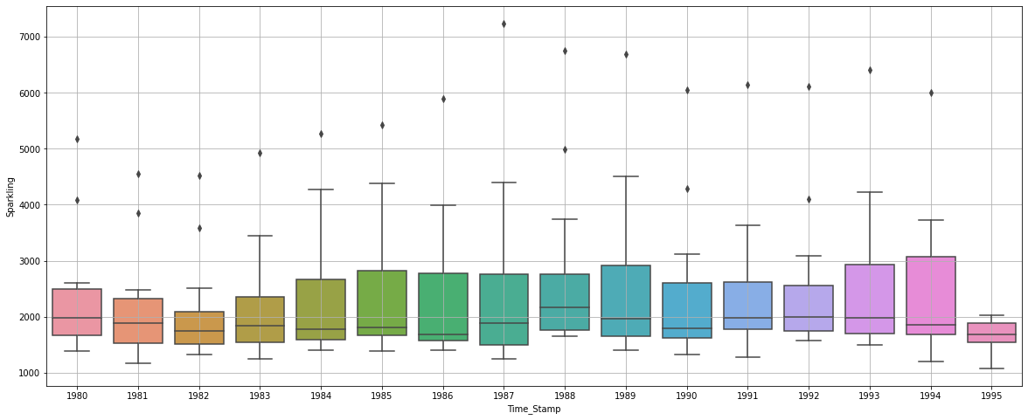

***Figure 2(a)***

* It can be observed that initially the yearly data has a upward trend, with the highest median value being in the year 1993.

## Monthly Boxplot

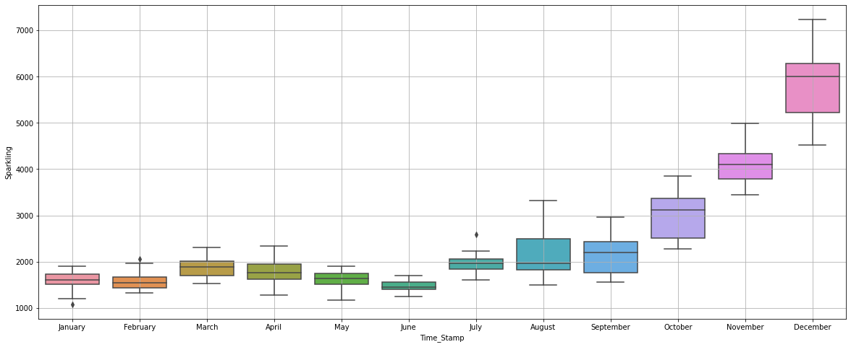

***Figure 2(b)***

* It can be observed that monthly data has an exponential increasing trend, with the highest median value being in the month of December.

## Rose Dataset

## Yearly Boxplot

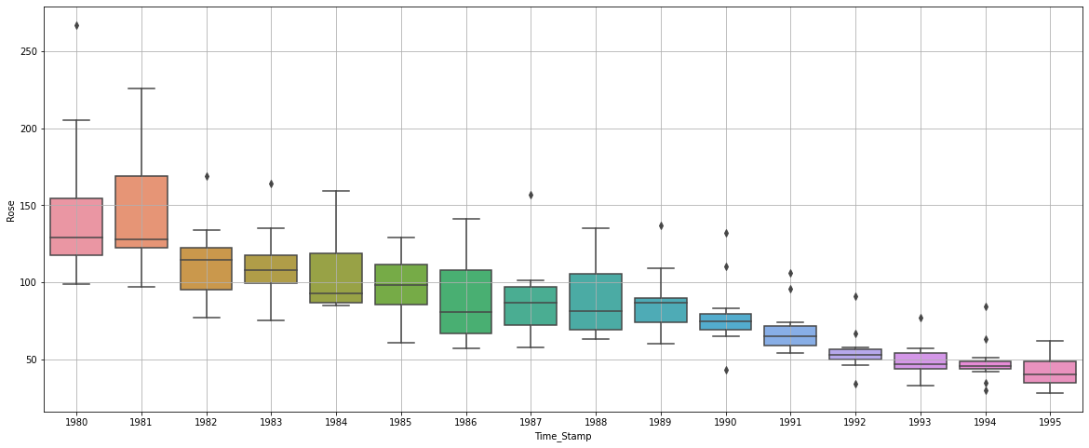

***Figure 2(c)***

* It can be observed that the yearly data has a exponentially decreasing trend, with the lowest median value being in the year 1995.

## Monthly Boxplot

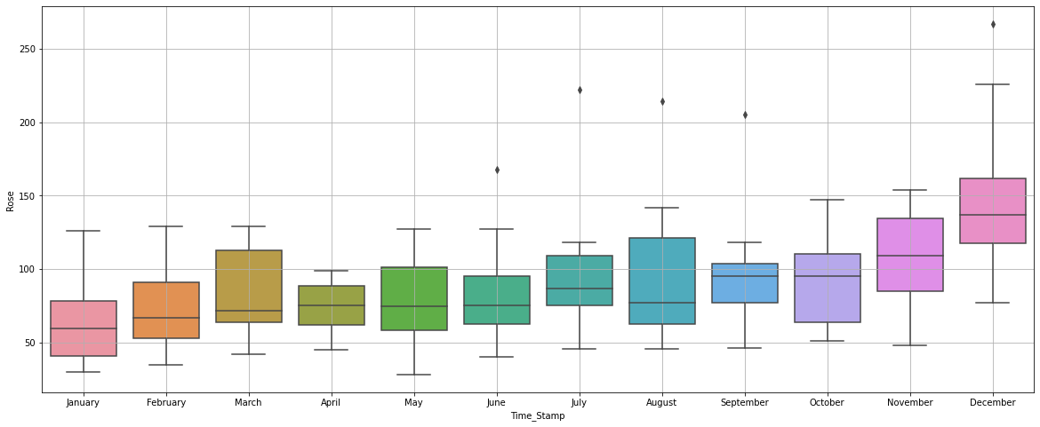

***Figure 2(d)***

* It can be observed that monthly data has an increasing trend, with the highest median value being in the month of December.

## 2.2 Plot a time series monthplot to understand the spread across different years and within different months across years

**SPARKLING  
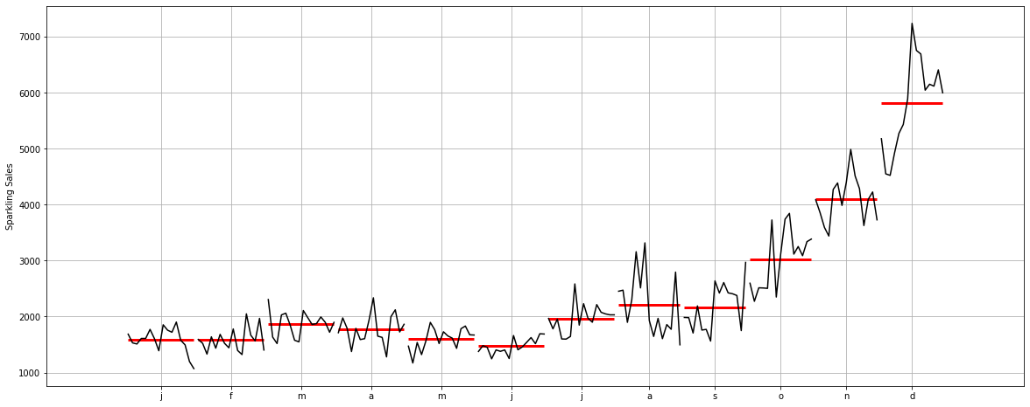**

***Figure 2.2(a)***

This plot shows us the behaviour of the Time Series ('Sparkling' in this case) across various months. The red line is the median value, which is the maximum for December.

**ROSE**

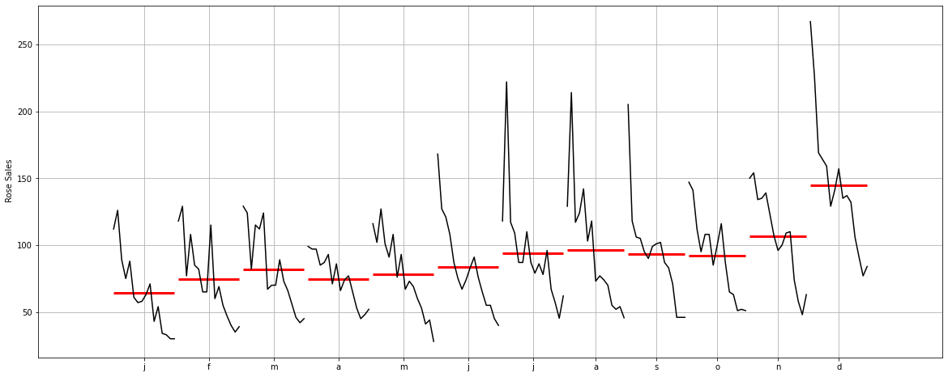

***Figure 2.2(b)***

This plot shows us the behaviour of the Time Series ('Rose' in this case) across various months. The red line is the median value, which is the maximum for December.

## Plot a graph of monthly Sparkling Sales across years.

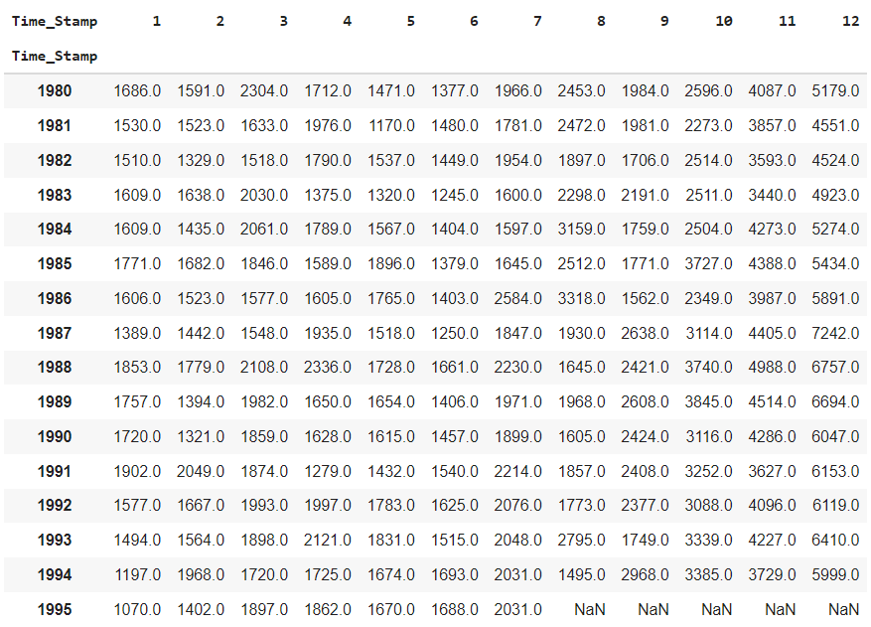

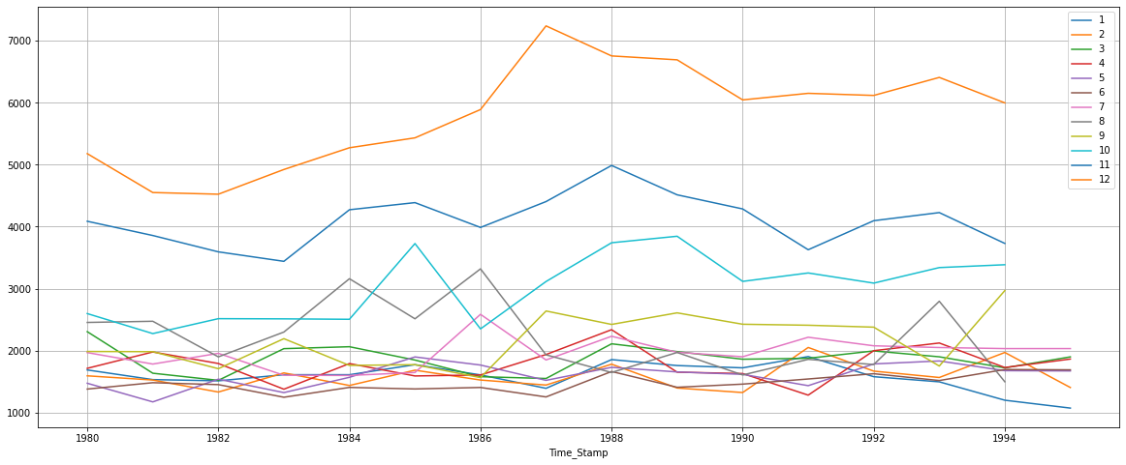

***Figure 2.2(c)***

* Similar observation, the orange line i.e. December holds the maximum sales.

## Plot a graph of monthly Rose Sales across years.

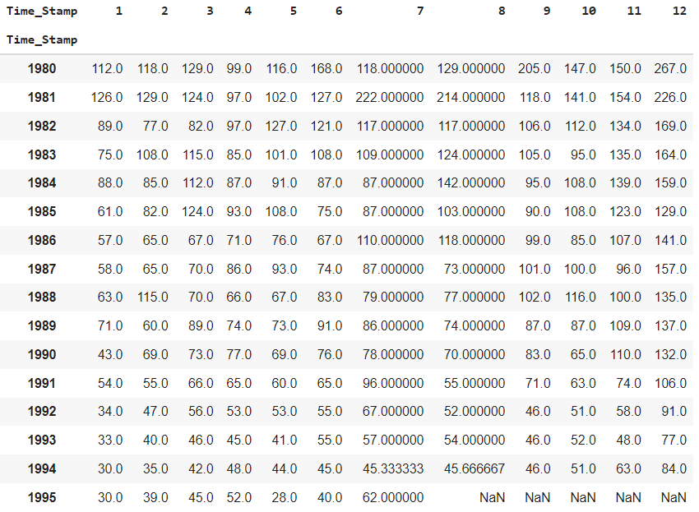

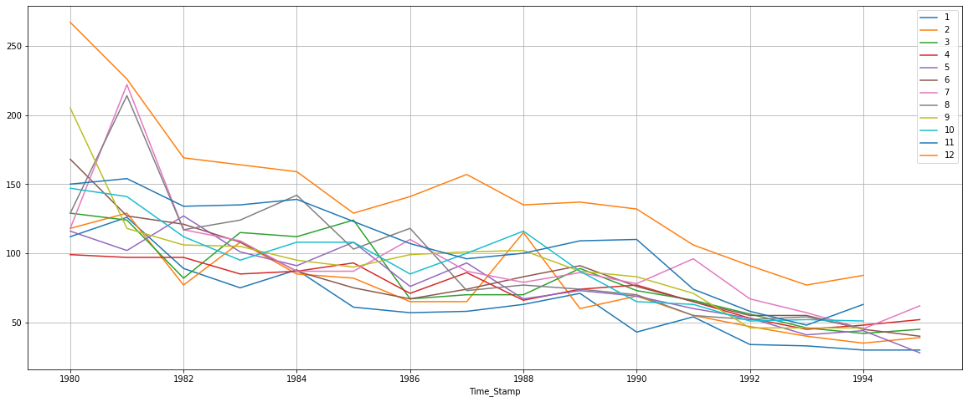

***Figure 2.2(d)***

* Similar observation, the orange line i.e. December holds the maximum sales.

## Plot the Empirical Cumulative Distribution.

SPARKLING

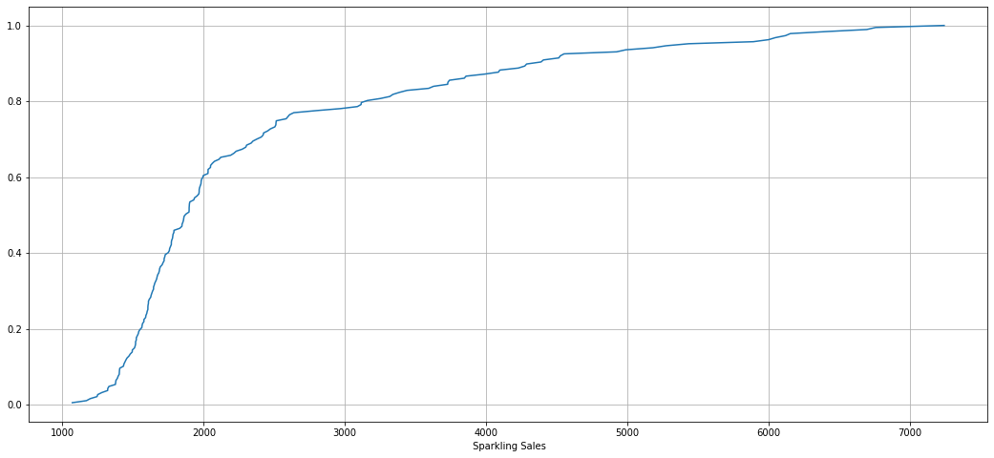

***Figure 2.3(a)***

ROSE

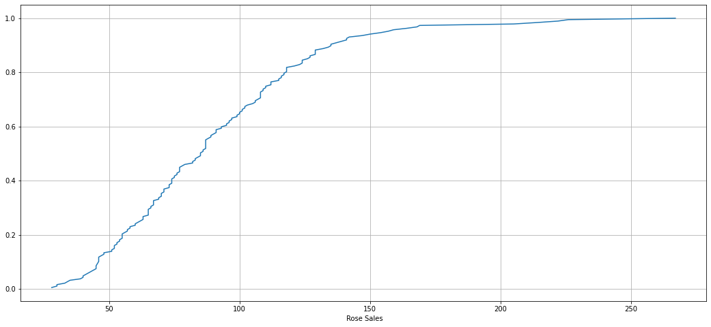

***Figure 2.3(b)***

## Plot the average Sparkling Sales per month and the month on month percentage change of Sparkling Sales.

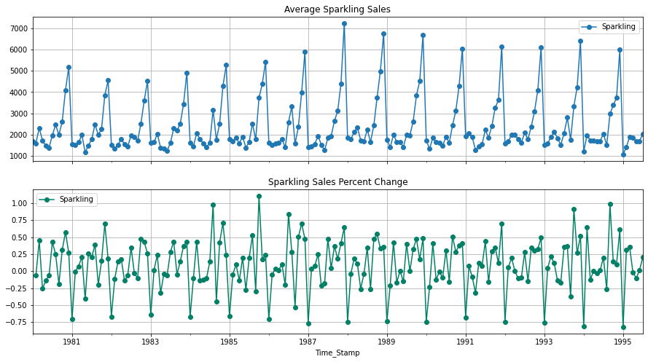

***Figure 2.4(a)***

* The maximum average sales recorded is 7000.
* The Percentage Change varies between the range of -1 to 1 which shows less fluctuation and is a good indication.

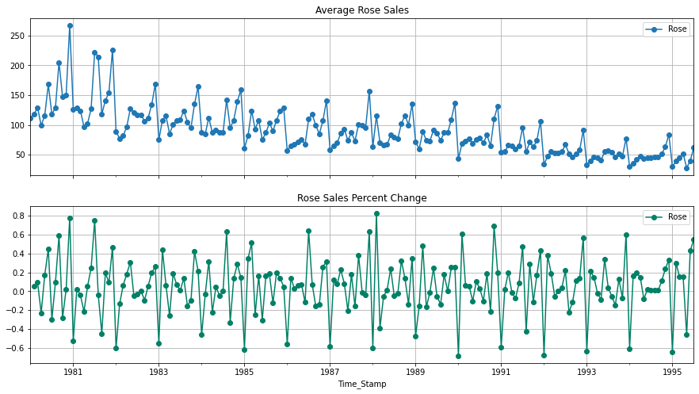

***Figure 2.4(b)***

* The maximum average sales recorded is around 275.
* The Percentage Change varies between the range of -0.7 to 0.8 which shows less fluctuation and is a good indication.

## Decompose the Time Series and plot the different components.

## Additive Decomposition

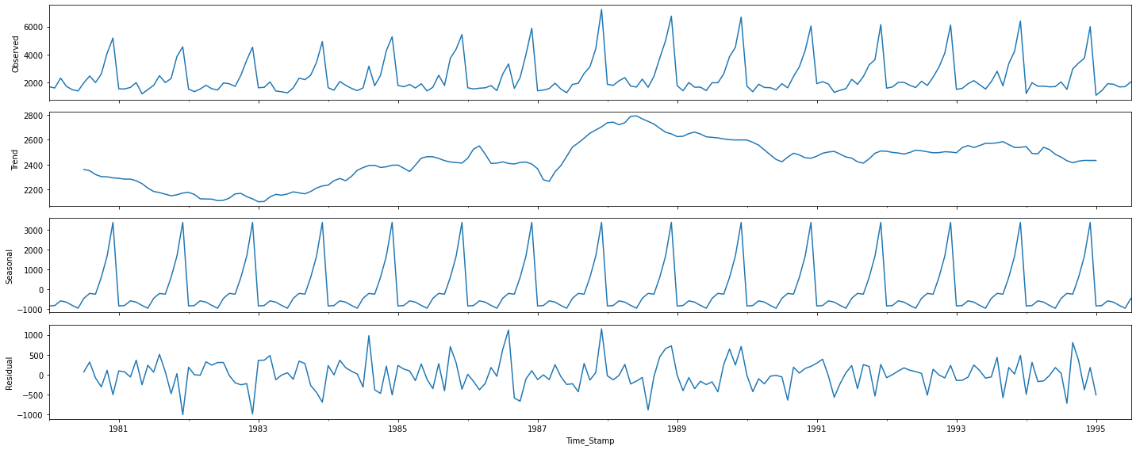

***Figure 2.5(a)***

* We can observe a slight upward trend present in our data.
* There’s definitely seasonality present in our data which will be calculated later.
* The Residuals lie in the range of -1000 to 1000 therefore its unlikely we will choose this decomposition method.

Trend

Time_Stamp

1980-01-31 NaN

1980-02-29 NaN

1980-03-31 NaN

1980-04-30 NaN

1980-05-31 NaN

1980-06-30 NaN

1980-07-31 2360.666667

1980-08-31 2351.333333

1980-09-30 2320.541667

1980-10-31 2303.583333

1980-11-30 2302.041667

1980-12-31 2293.791667

Name: Sparkling, dtype: float64

Seasonality

Time_Stamp

1980-01-31 -854.260599

1980-02-29 -830.350678

1980-03-31 -592.356630

1980-04-30 -658.490559

1980-05-31 -824.416154

1980-06-30 -967.434011

1980-07-31 -465.502265

1980-08-31 -214.332821

1980-09-30 -254.677265

1980-10-31 599.769957

1980-11-30 1675.067179

1980-12-31 3386.983846

Name: Sparkling, dtype: float64

Residual

Time_Stamp

1980-01-31 NaN

1980-02-29 NaN

1980-03-31 NaN

1980-04-30 NaN

1980-05-31 NaN

1980-06-30 NaN

1980-07-31 70.835599

1980-08-31 315.999487

1980-09-30 -81.864401

1980-10-31 -307.353290

1980-11-30 109.891154

1980-12-31 -501.775513

Name: Sparkling, dtype: float64

## Multiplicative Decomposition

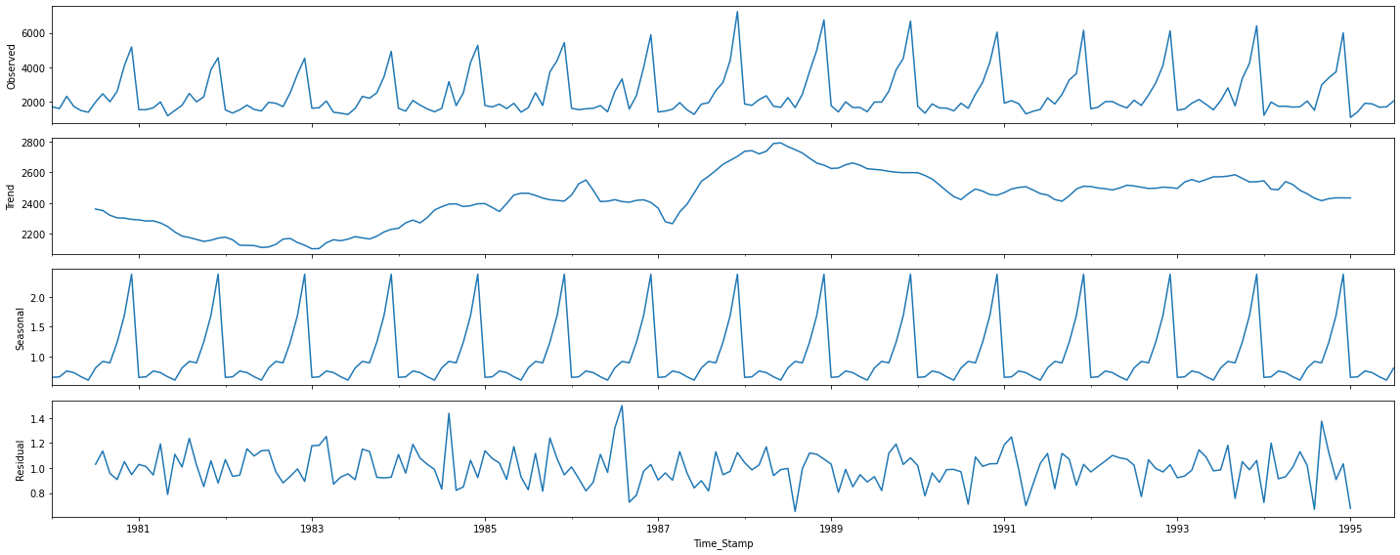

***Figure 2.5(b)***

* We can observe a slight upward trend present in our data.
* There’s definitely seasonality present in our data which will be calculated later.
* The Residuals lie in the range of 0.6 to 1.6 therefore we will choose this decomposition method.

Trend

Time_Stamp

1980-01-31 NaN

1980-02-29 NaN

1980-03-31 NaN

1980-04-30 NaN

1980-05-31 NaN

1980-06-30 NaN

1980-07-31 2360.666667

1980-08-31 2351.333333

1980-09-30 2320.541667

1980-10-31 2303.583333

1980-11-30 2302.041667

1980-12-31 2293.791667

Name: Sparkling, dtype: float64

Seasonality

Time_Stamp

1980-01-31 0.649843

1980-02-29 0.659214

1980-03-31 0.757440

1980-04-30 0.730351

1980-05-31 0.660609

1980-06-30 0.603468

1980-07-31 0.809164

1980-08-31 0.918822

1980-09-30 0.894367

1980-10-31 1.241789

1980-11-30 1.690158

1980-12-31 2.384776

Name: Sparkling, dtype: float64

Residual

Time_Stamp

1980-01-31 NaN

1980-02-29 NaN

1980-03-31 NaN

1980-04-30 NaN

1980-05-31 NaN

1980-06-30 NaN

1980-07-31 1.029230

1980-08-31 1.135407

1980-09-30 0.955954

1980-10-31 0.907513

1980-11-30 1.050423

1980-12-31 0.946770

Name: Sparkling, dtype: float64

## Check for stationarity of the whole Time Series Sparkling data.

To Check Stationarity we’ll define our Null ( Ho) and Alternate (Ha) hypothesis

Ho = The Time Series is Not Stationary

Ha = The Time Series is Stationary

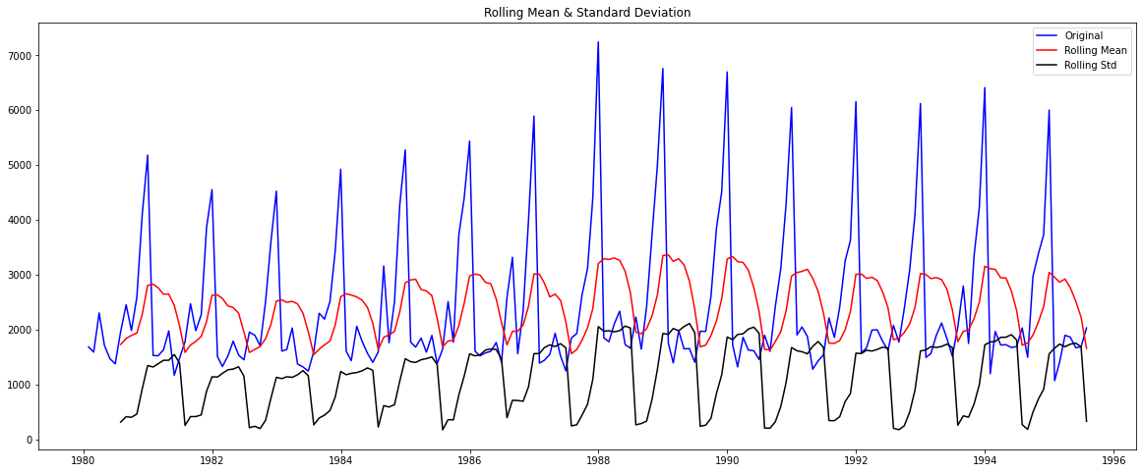

***Figure 2.5(c)***

Results of Dickey-Fuller Test:

Test Statistic -1.360497

p-value 0.601061

#Lags Used 11.000000

Number of Observations Used 175.000000

Critical Value (1%) -3.468280

Critical Value (5%) -2.878202

Critical Value (10%) -2.575653

dtype: float64

* Since p-value > alpha (0.05). Ho holds true, i.e Time Series is not Stationary

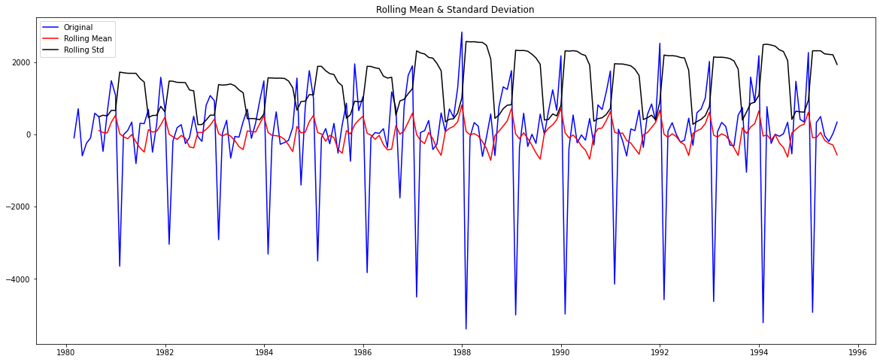

***Figure 2.5(d)***

Results of Dickey-Fuller Test:

Test Statistic -45.050301

p-value 0.000000

#Lags Used 10.000000

Number of Observations Used 175.000000

Critical Value (1%) -3.468280

Critical Value (5%) -2.878202

Critical Value (10%) -2.575653

dtype: float64

* Since p-value < alpha (0.05). Ho is rejected, i.e Time Series is Stationary

**ROSE DATASET**

## Additional Decoposition

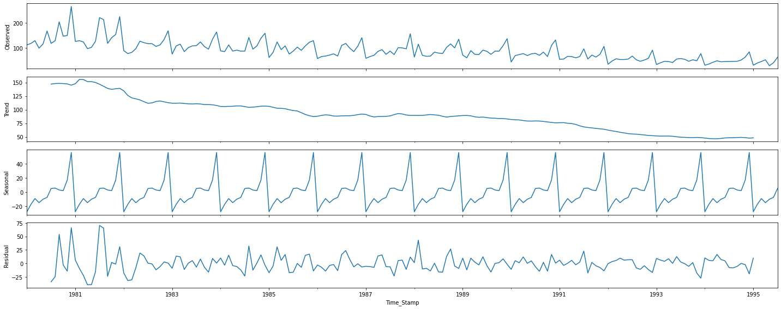

***Figure 2.6(a)***

* We can observe a downward trend present in our data.
* There’s definitely seasonality present in our data which will be calculated later.
* The Residuals lie in the range of -25 to 75 therefore its unlikely we will choose this decomposition method.

Trend

Time_Stamp

1980-01-31 NaN

1980-02-29 NaN

1980-03-31 NaN

1980-04-30 NaN

1980-05-31 NaN

1980-06-30 NaN

1980-07-31 147.083333

1980-08-31 148.125000

1980-09-30 148.375000

1980-10-31 148.083333

1980-11-30 147.416667

1980-12-31 145.125000

Name: Rose, dtype: float64

Seasonality

Time_Stamp

1980-01-31 -27.908647

1980-02-29 -17.435632

1980-03-31 -9.285830

1980-04-30 -15.098330

1980-05-31 -10.196544

1980-06-30 -7.678687

1980-07-31 4.896908

1980-08-31 5.499686

1980-09-30 2.774686

1980-10-31 1.871908

1980-11-30 16.846908

1980-12-31 55.713575

Name: Rose, dtype: float64

Residual

Time_Stamp

1980-01-31 NaN

1980-02-29 NaN

1980-03-31 NaN

1980-04-30 NaN

1980-05-31 NaN

1980-06-30 NaN

1980-07-31 -33.980241

1980-08-31 -24.624686

1980-09-30 53.850314

1980-10-31 -2.955241

1980-11-30 -14.263575

1980-12-31 66.161425

Name: Rose, dtype: float64

## Multiplicative Decomposition

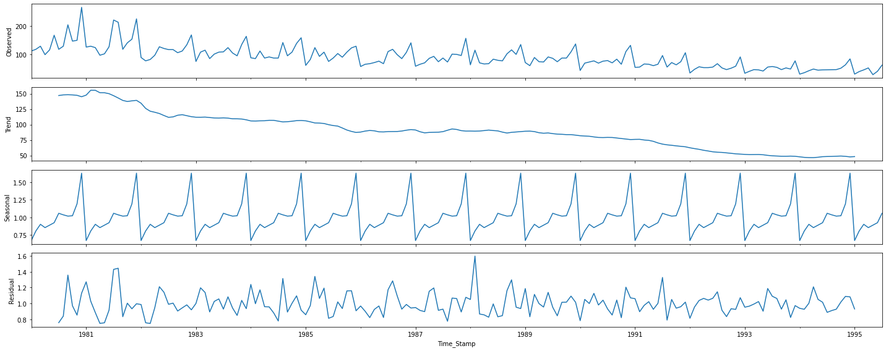

***Figure 2.6(b)***

* We can observe a downward trend present in our data.
* There’s definitely seasonality present in our data which will be calculated later.
* The Residuals lie in the range of 0.6 to 1.6 therefore we will choose this decomposition method.

Trend

Time_Stamp

1980-01-31 NaN

1980-02-29 NaN

1980-03-31 NaN

1980-04-30 NaN

1980-05-31 NaN

1980-06-30 NaN

1980-07-31 147.083333

1980-08-31 148.125000

1980-09-30 148.375000

1980-10-31 148.083333

1980-11-30 147.416667

1980-12-31 145.125000

Name: Rose, dtype: float64

Seasonality

Time_Stamp

1980-01-31 0.670111

1980-02-29 0.806163

1980-03-31 0.901164

1980-04-30 0.854024

1980-05-31 0.889415

1980-06-30 0.923985

1980-07-31 1.058038

1980-08-31 1.035881

1980-09-30 1.017648

1980-10-31 1.022573

1980-11-30 1.192349

1980-12-31 1.628646

Name: Rose, dtype: float64

Residual

Time_Stamp

1980-01-31 NaN

1980-02-29 NaN

1980-03-31 NaN

1980-04-30 NaN

1980-05-31 NaN

1980-06-30 NaN

1980-07-31 0.758258

1980-08-31 0.840720

1980-09-30 1.357674

1980-10-31 0.970771

1980-11-30 0.853378

1980-12-31 1.129646

Name: Rose, dtype: float64

## Check for stationarity of the whole Time Series Rose data.

To Check Stationarity we’ll define our Null ( Ho) and Alternate (Ha) hypothesis

Ho = The Time Series is Not Stationary

Ha = The Time Series is Stationary

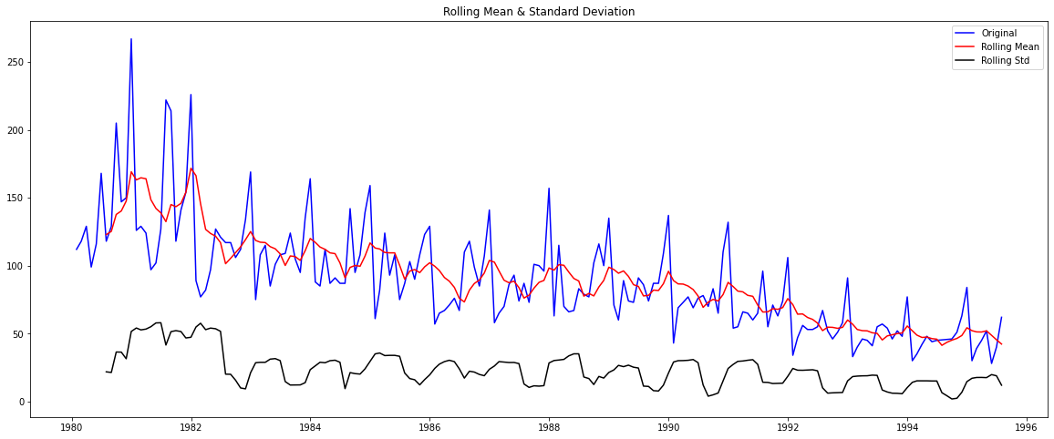

***Figure 2.6(c)***

Results of Dickey-Fuller Test:

Test Statistic -1.876699

p-value 0.343101

#Lags Used 13.000000

Number of Observations Used 173.000000

Critical Value (1%) -3.468726

Critical Value (5%) -2.878396

Critical Value (10%) -2.575756

dtype: float64

* Since p-value > alpha (0.05). Ho holds true, i.e Time Series is not Stationary

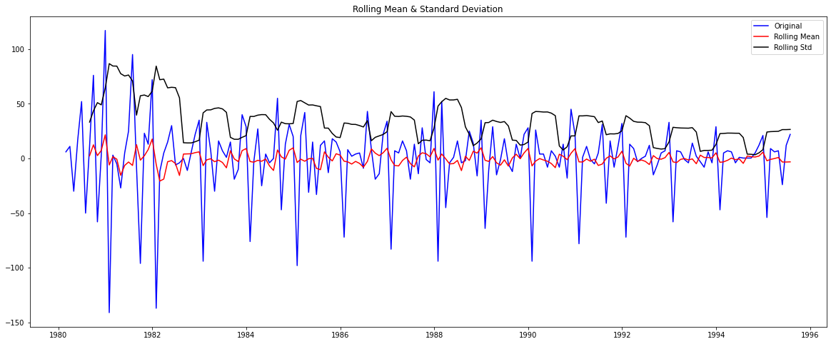

***Figure 2.6(d)***

Results of Dickey-Fuller Test:

Test Statistic -8.044392e+00

p-value 1.810895e-12

#Lags Used 1.200000e+01

Number of Observations Used 1.730000e+02

Critical Value (1%) -3.468726e+00

Critical Value (5%) -2.878396e+00

Critical Value (10%) -2.575756e+00

dtype: float64

* Since p-value < alpha (0.05). Ho is rejected, i.e Time Series is Stationary

## Plot the Autocorrelation and the Partial Autocorrelation function plots on the whole data

**Sparkling - ACF**

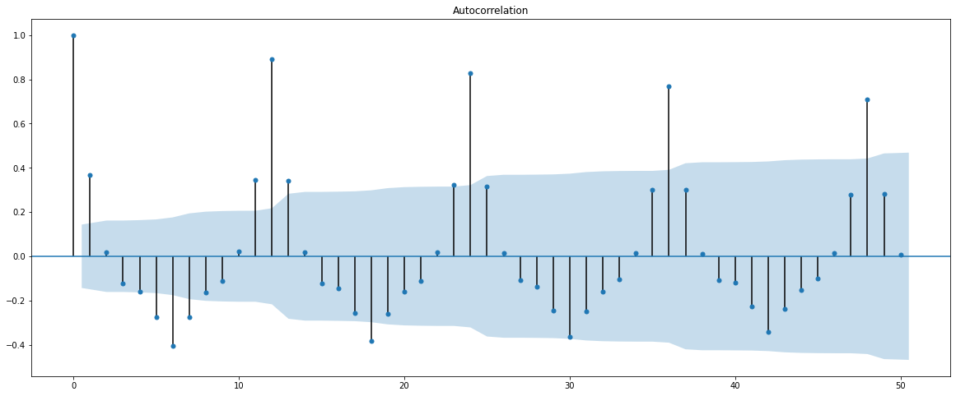

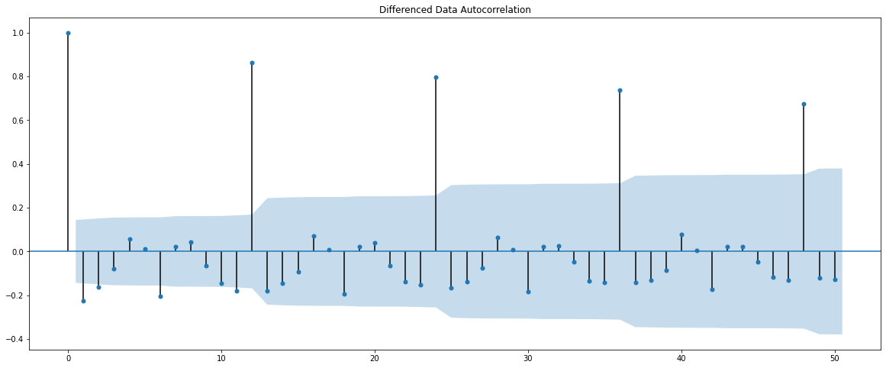

***Figure 2.7(a)***

**PACF**

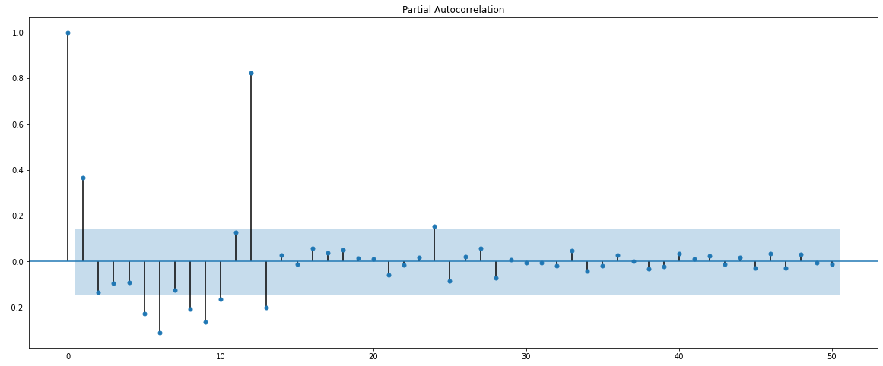

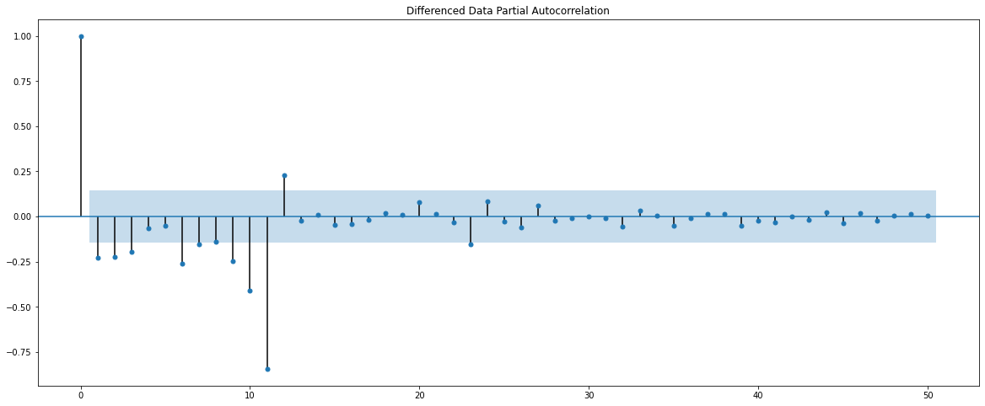

***Figure 2.7(b)***

*The ACF cuts off after lag 2 and PACF after lag 3, therefore our p=3 and q=2 which will be used to build ARIMA/SARIMA models.*

**Rose - ACF**

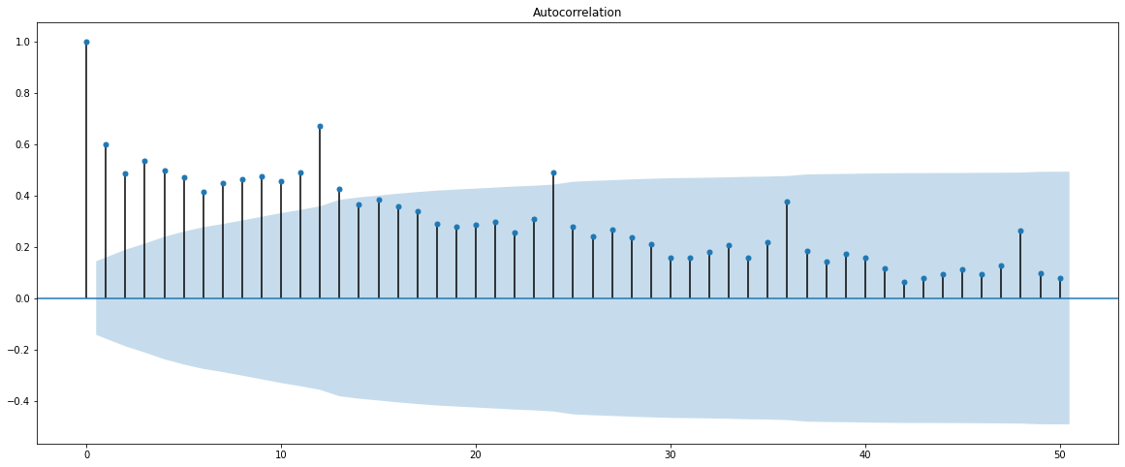

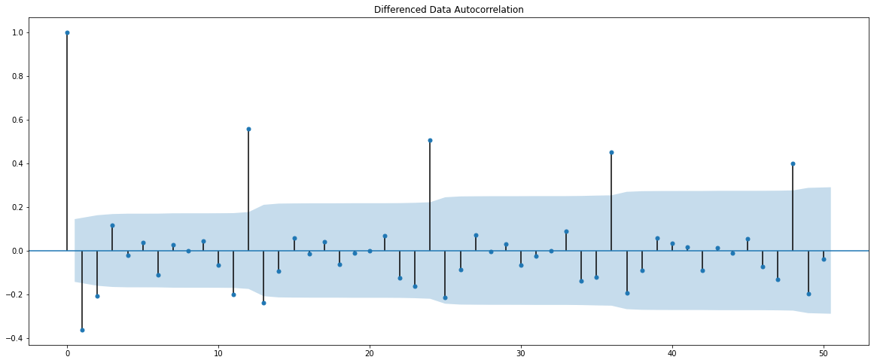

***Figure 2.7(c)***

**PACF**

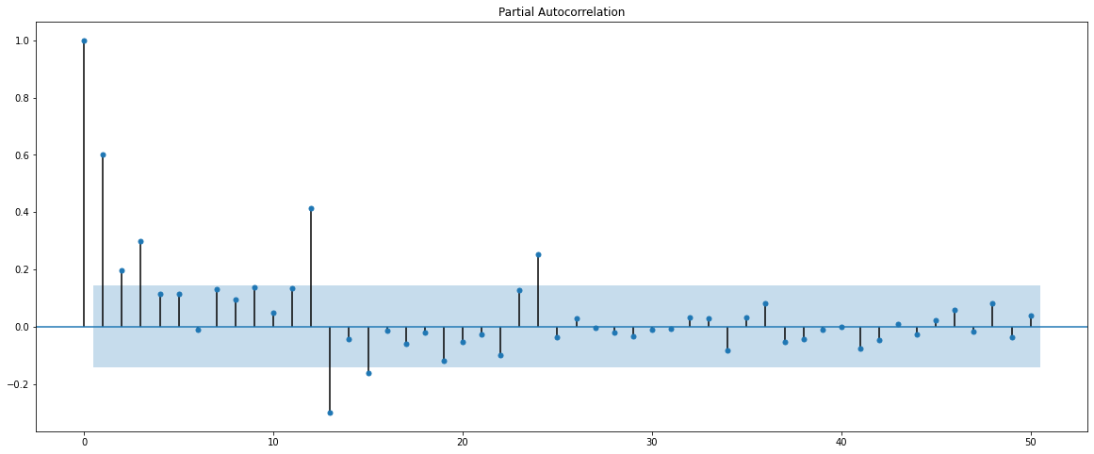

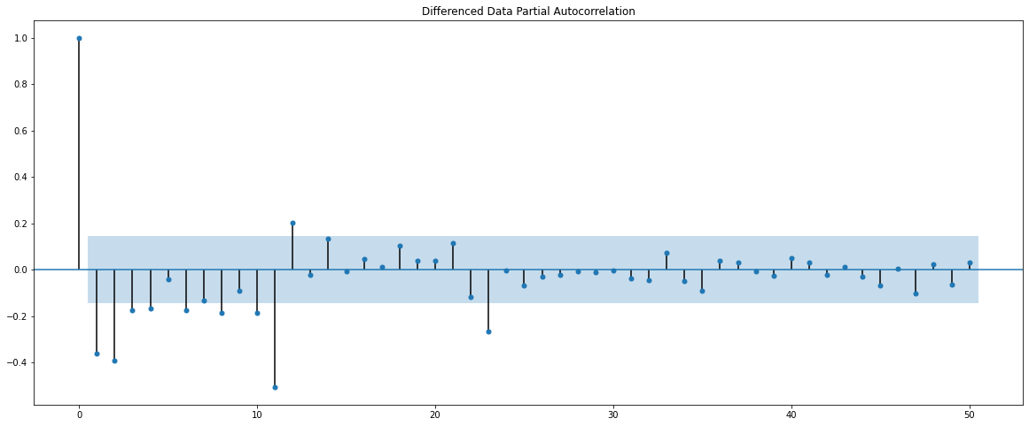

***Figure 2.7(d)***

*The ACF cuts off after lag 2 and PACF after lag 4, therefore our p=3 and q=2 which will be used to build ARIMA/SARIMA models.*

*We have taken p as 3 and not 4 is to reduce model complexity.*

## Split the data into training and test. The test data should start in 1991.

|  |  |
| --- | --- |
|  |  |

*The total number of rows present in the* ***‘training’*** *dataset above is : 132*

*The total number of rows present in the ‘****testing’*** *dataset above is : 55*

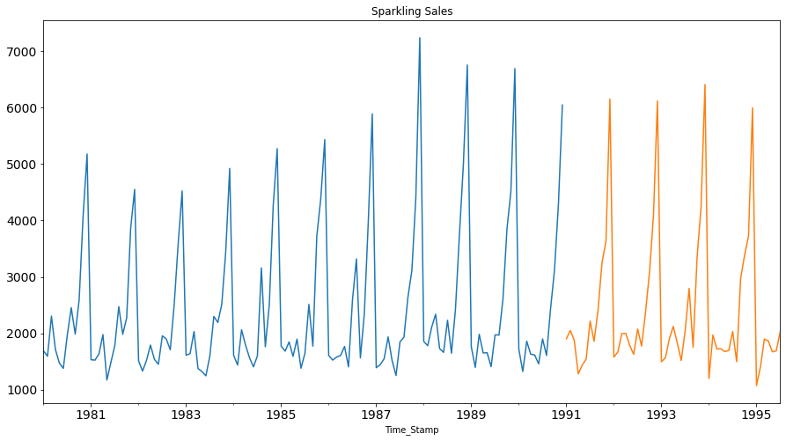

***Figure 3(a)***

|  |  |
| --- | --- |
|  |  |

*The total number of rows present in the* ***‘training’*** *dataset above is : 132*

*The total number of rows present in the ‘****testing’*** *dataset above is : 55*

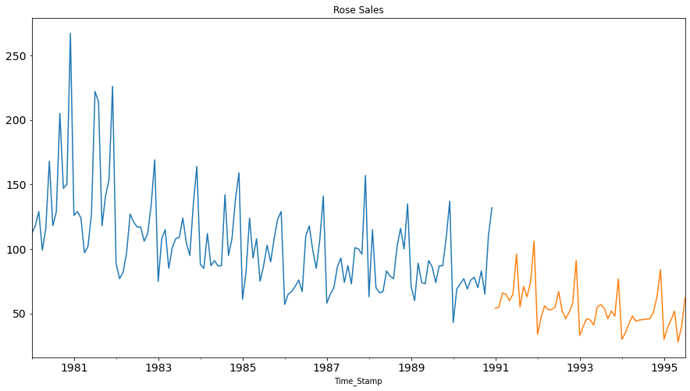

***Figure 3(b)***

## Build various exponential smoothing models on the training data and evaluate the model using RMSE on the test data.

## Building different models and comparing the accuracy metrics.

## Model 1: Linear Regression

SPARKLING

Training Time instance

[1, 2, 3, 4, 5, 6, 7, 8, 9, 10, 11, 12, 13, 14, 15, 16, 17, 18, 19, 20, 21, 22, 23, 24, 25, 26, 27, 28, 29, 30, 31, 32, 33, 34, 35, 36, 37, 38, 39, 40, 41, 42, 43, 44, 45, 46, 47, 48, 49, 50, 51, 52, 53, 54, 55, 56, 57, 58, 59, 60, 61, 62, 63, 64, 65, 66, 67, 68, 69, 70, 71, 72, 73, 74, 75, 76, 77, 78, 79, 80, 81, 82, 83, 84, 85, 86, 87, 88, 89, 90, 91, 92, 93, 94, 95, 96, 97, 98, 99, 100, 101, 102, 103, 104, 105, 106, 107, 108, 109, 110, 111, 112, 113, 114, 115, 116, 117, 118, 119, 120, 121, 122, 123, 124, 125, 126, 127, 128, 129, 130, 131, 132]

Test Time instance

[133, 134, 135, 136, 137, 138, 139, 140, 141, 142, 143, 144, 145, 146, 147, 148, 149, 150, 151, 152, 153, 154, 155, 156, 157, 158, 159, 160, 161, 162, 163, 164, 165, 166, 167, 168, 169, 170, 171, 172, 173, 174, 175, 176, 177, 178, 179, 180, 181, 182, 183, 184, 185, 186, 187]

We see that we have successfully the generated the numerical time instance order for both the training and test set. Now we will add these values in the training and test set.

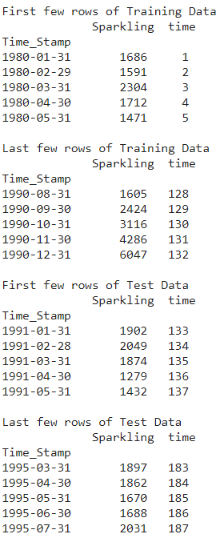



Now that our training and test data has been modified, let us go ahead use 𝐿𝑖𝑛𝑒𝑎𝑟𝑅𝑒𝑔𝑟𝑒𝑠𝑠𝑖𝑜𝑛 to build the model on the training data and test the model on the test data.

LinearRegression(copy_X=True, fit_intercept=True, n_jobs=None, normalize=False)

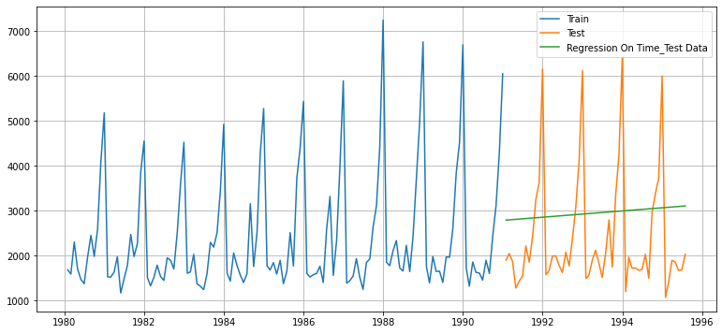

***Figure 4.1(a)***

## Defining the accuracy metrics.

## Model Evaluation

* ***For RegressionOnTime forecast on the Test Data, RMSE is* 1389.135**

ROSE

Training Time instance

[1, 2, 3, 4, 5, 6, 7, 8, 9, 10, 11, 12, 13, 14, 15, 16, 17, 18, 19, 20, 21, 22, 23, 24, 25, 26, 27, 28, 29, 30, 31, 32, 33, 34, 35, 36, 37, 38, 39, 40, 41, 42, 43, 44, 45, 46, 47, 48, 49, 50, 51, 52, 53, 54, 55, 56, 57, 58, 59, 60, 61, 62, 63, 64, 65, 66, 67, 68, 69, 70, 71, 72, 73, 74, 75, 76, 77, 78, 79, 80, 81, 82, 83, 84, 85, 86, 87, 88, 89, 90, 91, 92, 93, 94, 95, 96, 97, 98, 99, 100, 101, 102, 103, 104, 105, 106, 107, 108, 109, 110, 111, 112, 113, 114, 115, 116, 117, 118, 119, 120, 121, 122, 123, 124, 125, 126, 127, 128, 129, 130, 131, 132]

Test Time instance

[133, 134, 135, 136, 137, 138, 139, 140, 141, 142, 143, 144, 145, 146, 147, 148, 149, 150, 151, 152, 153, 154, 155, 156, 157, 158, 159, 160, 161, 162, 163, 164, 165, 166, 167, 168, 169, 170, 171, 172, 173, 174, 175, 176, 177, 178, 179, 180, 181, 182, 183, 184, 185, 186, 187]

We see that we have successfully the generated the numerical time instance order for both the training and test set. Now we will add these values in the training and test set.

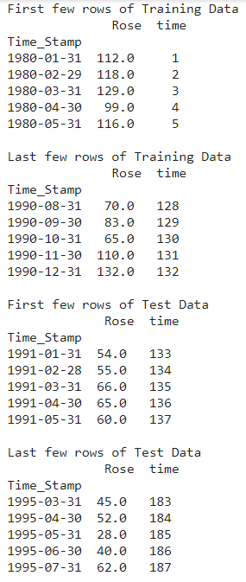 

Now that our training and test data has been modified, let us go ahead use 𝐿𝑖𝑛𝑒𝑎𝑟𝑅𝑒𝑔𝑟𝑒𝑠𝑠𝑖𝑜𝑛 to build the model on the training data and test the model on the test data.

LinearRegression(copy_X=True, fit_intercept=True, n_jobs=None, normalize=False)

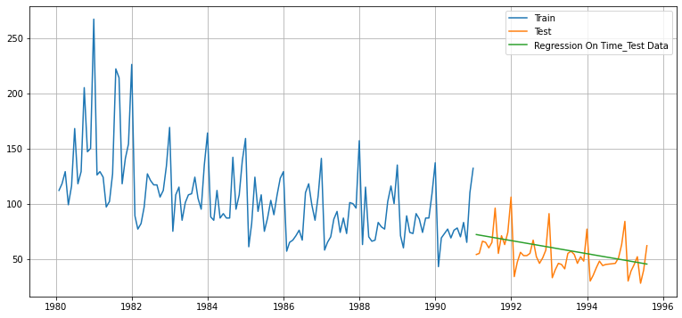

***Figure 4.1(b)***

## Defining the accuracy metrics.

## Model Evaluation

* ***For RegressionOnTime forecast on the Test Data, RMSE is 15.269***

## Model 2: Naive Approach: 𝑦̂ 𝑡+1=𝑦𝑡

For this particular naive model, we say that the prediction for tomorrow is the same as today and the prediction for day after tomorrow is tomorrow and since the prediction of tomorrow is same as today, therefore the prediction for day after tomorrow is also today.

SPARKLING

Tail of the Training set.

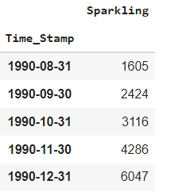

Head of the Naïve Model.

Time_Stamp

1991-01-31 6047

1991-02-28 6047

1991-03-31 6047

1991-04-30 6047

1991-05-31 6047

Name: naive, dtype: int64

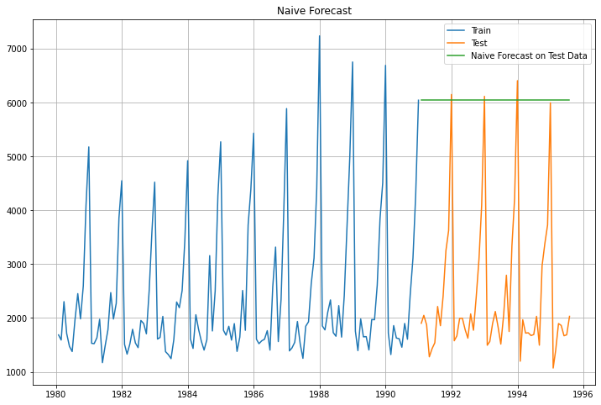

***Figure 4.2(a)***

## Model Evaluation

* **For NaïveModel forecast on the Test Data, RMSE is 3864.279**

ROSE

Tail of the Training set.

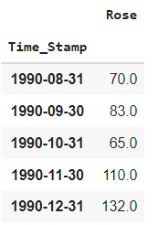

Head of the Naïve Model.

Time_Stamp

1991-01-31 132.0

1991-02-28 132.0

1991-03-31 132.0

1991-04-30 132.0

1991-05-31 132.0

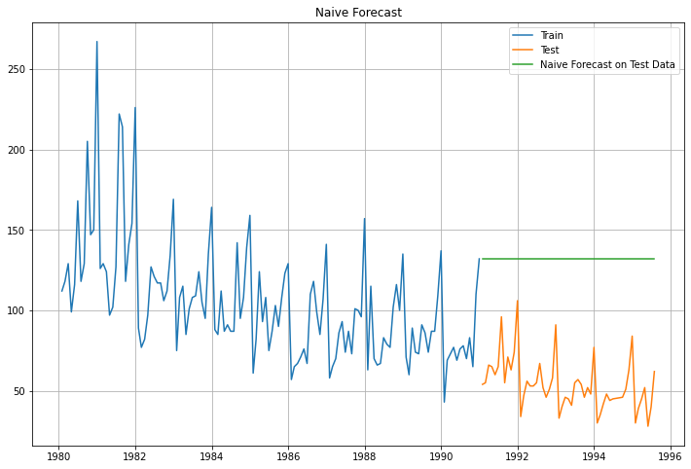

***Figure 4.2(b)***

## Model Evaluation

* **For NaiveModel forecast on the Test Data, RMSE is 79.719**

## Method 3: Simple Average

For this particular simple average method, we will forecast by using the average of the training values

SPARKLING

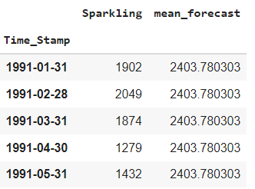

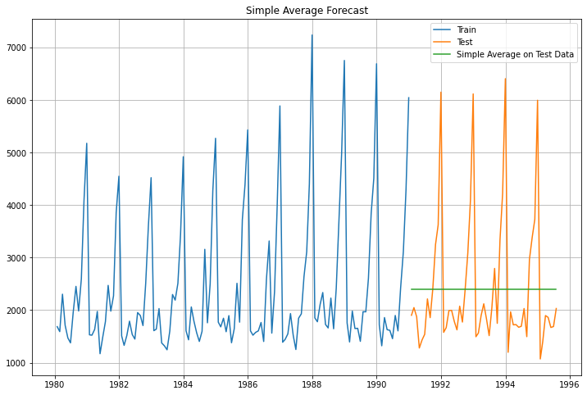

***Figure 4.3(a)***

## Model Evaluation

* ***For Simple Average forecast on the Test Data, RMSE is 1275.082***

ROSE

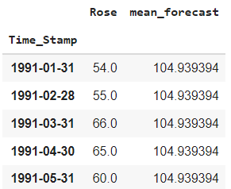

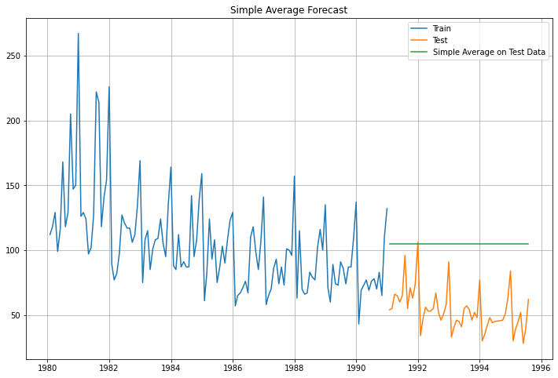

***Figure 4.3(b)***

## Model Evaluation

* **For Simple Average forecast on the Test Data, RMSE is 53.461**

## Method 4: Moving Average(MA)

For the moving average model, we are going to calculate rolling means (or moving averages) for different intervals. The best interval can be determined by the maximum accuracy (or the minimum error) over here.

For Moving Average, we are going to average over the entire data.

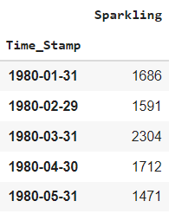

## Trailing moving averages

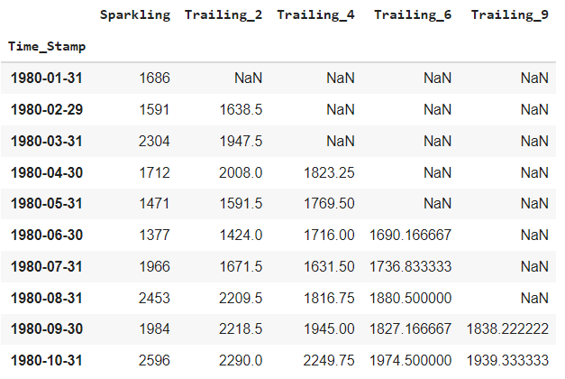

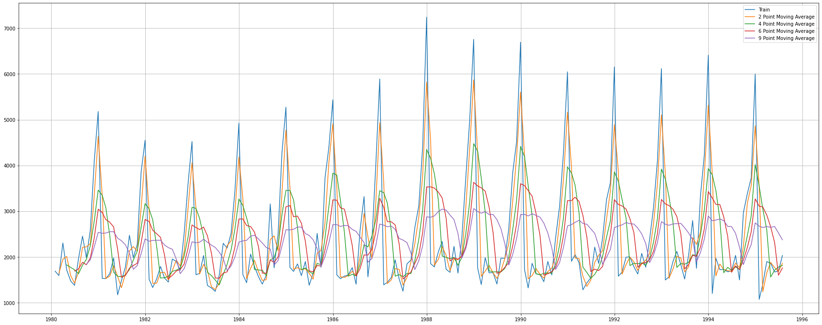

***Figure 4.4(a)***

Let us split the data into train and test and plot this Time Series. The window of the moving average is need to be carefully selected as too big a window will result in not having any test set as the whole series might get averaged over.

* TRAINING SET

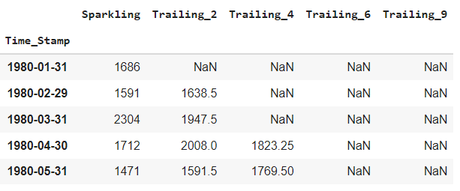

* TESTING SET

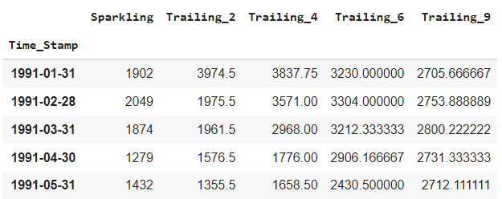

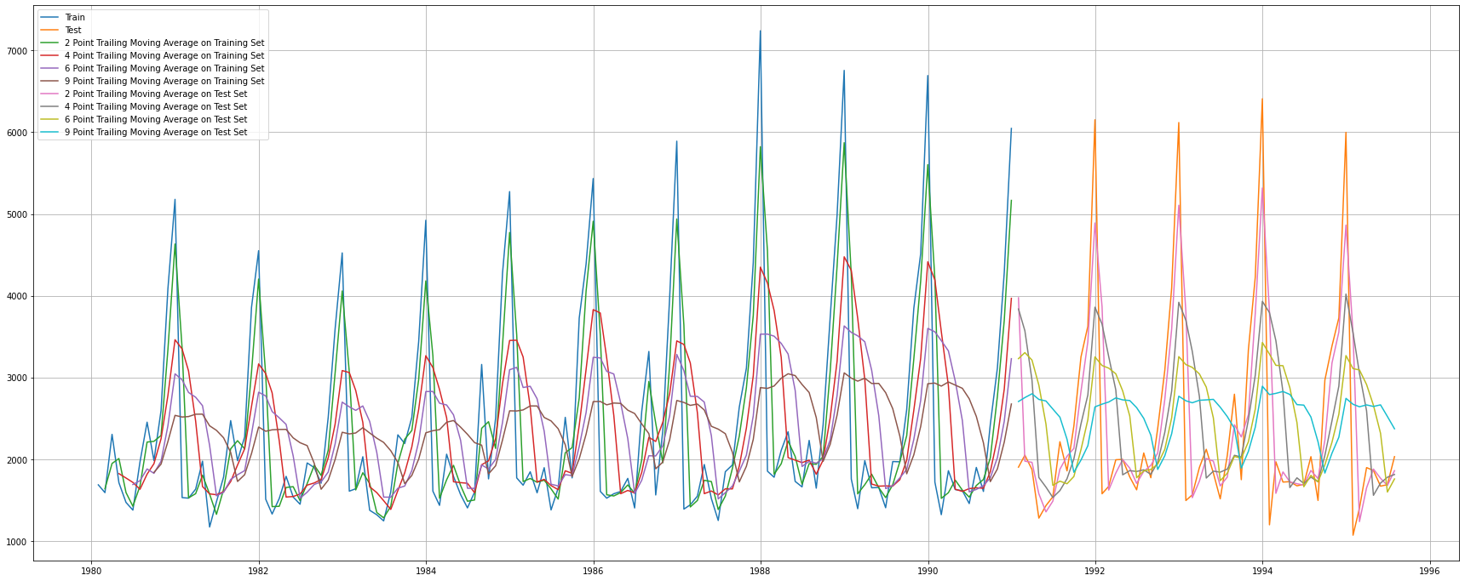

***Figure 4.4(b)***

## Model Evaluation

Done only on the test data

* **For 2 point Moving Average Model forecast on the Training Data, RMSE is 813.401**
* **For 4 point Moving Average Model forecast on the Training Data, RMSE is 1156.590**
* **For 6 point Moving Average Model forecast on the Training Data, RMSE is 1283.927**
* **For 9 point Moving Average Model forecast on the Training Data, RMSE is 1346.278**

ROSE

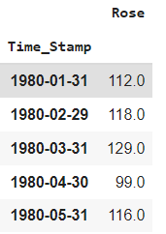

## Trailing moving averages

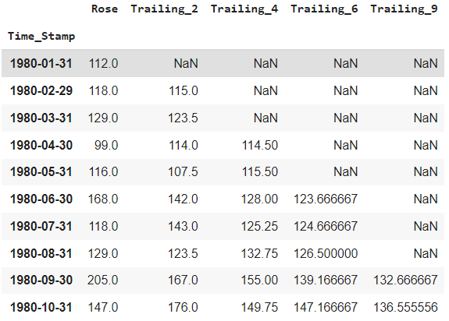

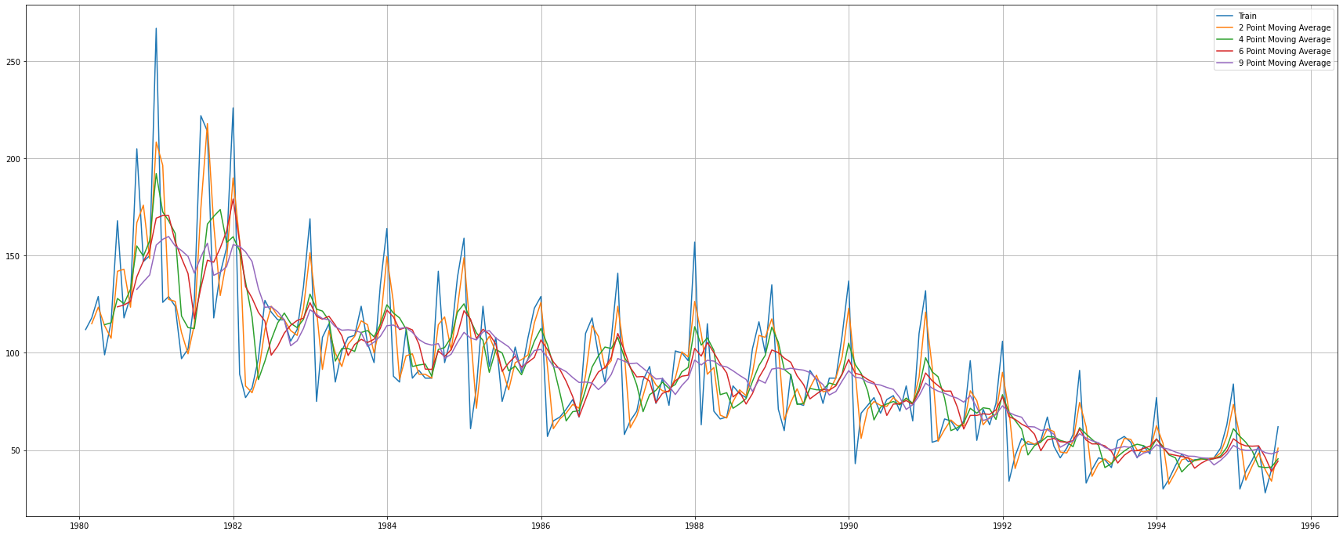

***Figure 4.4(c)***

Let us split the data into train and test and plot this Time Series. The window of the moving average is need to be carefully selected as too big a window will result in not having any test set as the whole series might get averaged over.

* TRAINING SET

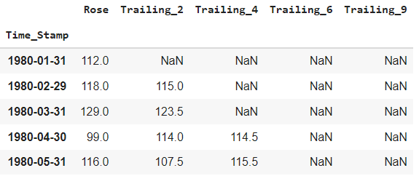

* TESTING SET

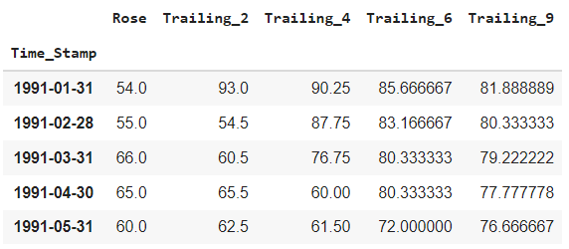

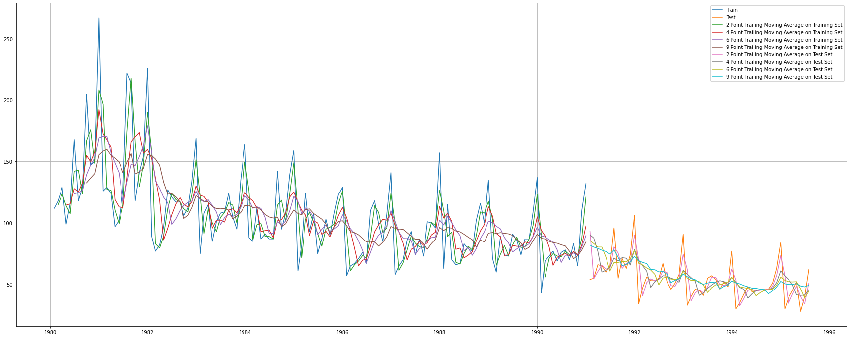

***Figure 4.4(d)***

## Model Evaluation

Done only on the test data

* **For 2 point Moving Average Model forecast on the Training Data, RMSE is 11.529**
* **For 4 point Moving Average Model forecast on the Training Data, RMSE is 14.451**
* **For 6 point Moving Average Model forecast on the Training Data, RMSE is 14.566**
* **For 9 point Moving Average Model forecast on the Training Data, RMSE is 14.728**

## Before we go on to build the various Exponential Smoothing models, let us plot all the models and compare the Time Series plots.

SPARKLING

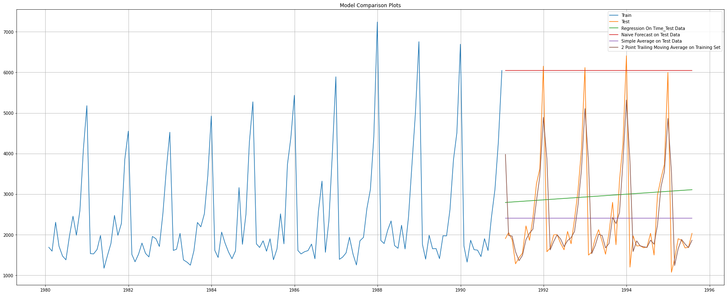

***Figure 4.4(e)***

ROSE

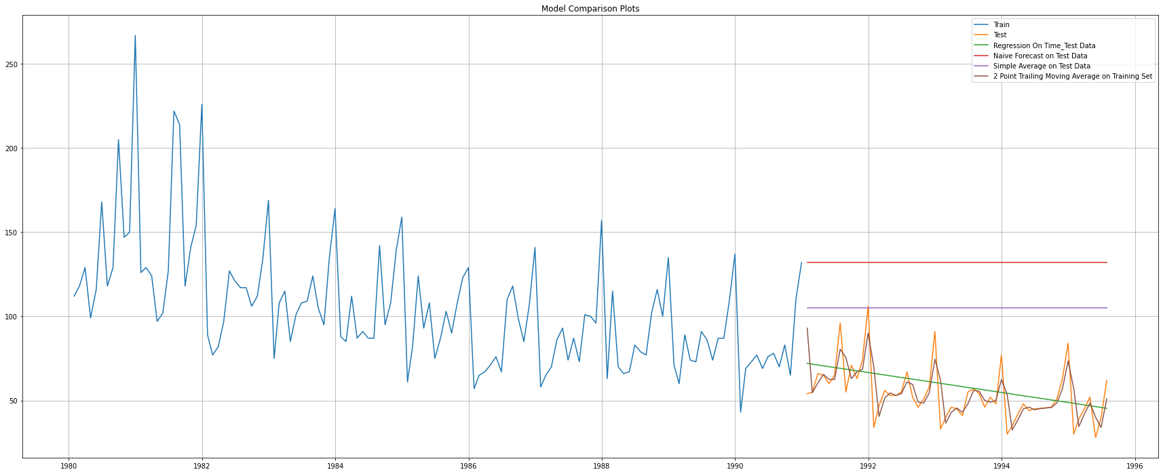

***Figure 4.4(f)***

## Method 5: Simple Exponential Smoothing

Automatically choosen parameters.

{'damping_slope': nan,

'initial_level': 2403.7828696439005,

'initial_seasons': array([], dtype=float64),

'initial_slope': nan,

'lamda': None,

'remove_bias': False,

'smoothing_level': 0.0,

'smoothing_seasonal': nan,

'smoothing_slope': nan,

'use_boxcox': False}

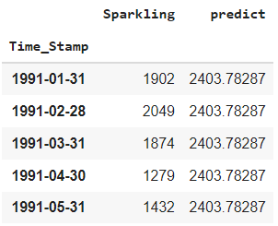

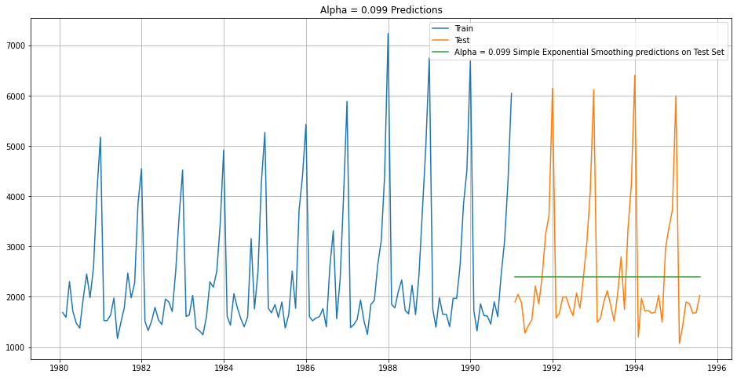

***Figure 4.5(a)***

## Model Evaluation for 𝛼 = 0.099 : Simple Exponential Smoothing

* For Alpha =0.099 Simple Exponential Smoothing Model forecast on the Test Data, RMSE is 1275.082

ROSE

{'damping_slope': nan,

'initial_level': 134.38712015111975,

'initial_seasons': array([], dtype=float64),

'initial_slope': nan,

'lamda': None,

'remove_bias': False,

'smoothing_level': 0.09875003987520162,

'smoothing_seasonal': nan,

'smoothing_slope': nan,

'use_boxcox': False}

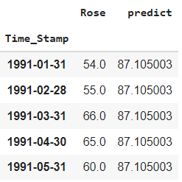

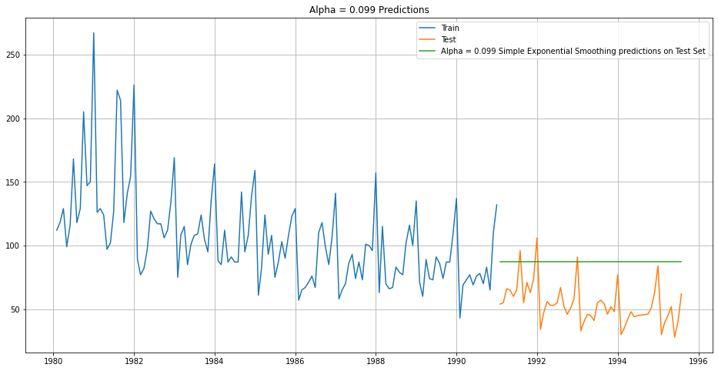

***Figure 4.5(b)***

## Model Evaluation for 𝛼 = 0.099 : Simple Exponential Smoothing

* For Alpha = 0.099 Simple Exponential Smoothing Model forecast on the Test Data, RMSE is 36.796

**Setting different alpha values.**

**Remember, the higher the alpha value more weightage is given to the more recent observation. That means, what happened recently will happen again.**

**We will run a loop with different alpha values to understand which particular value works best for alpha on the test set.**

## Model Evaluation

SPARKLING

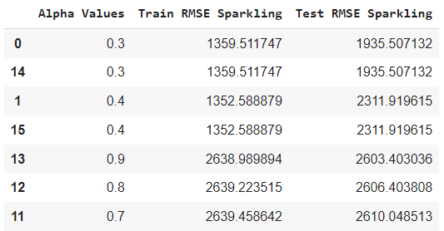

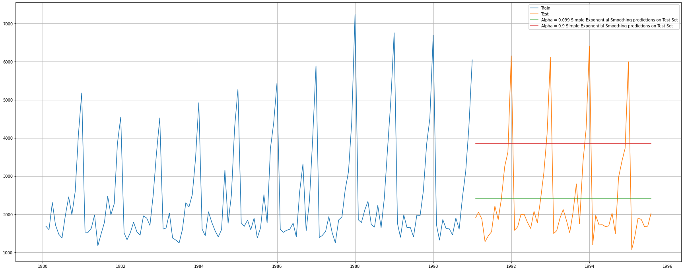

***Figure 4.5(c)***

* *AS OBSERVED, ALPHA = 0.3 IS THE ONE GIVING US THE LOWEST RMSE VALUE.*

ROSE

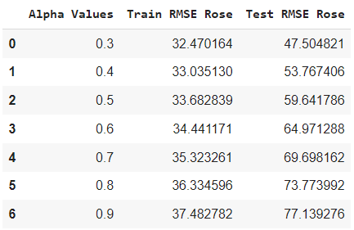

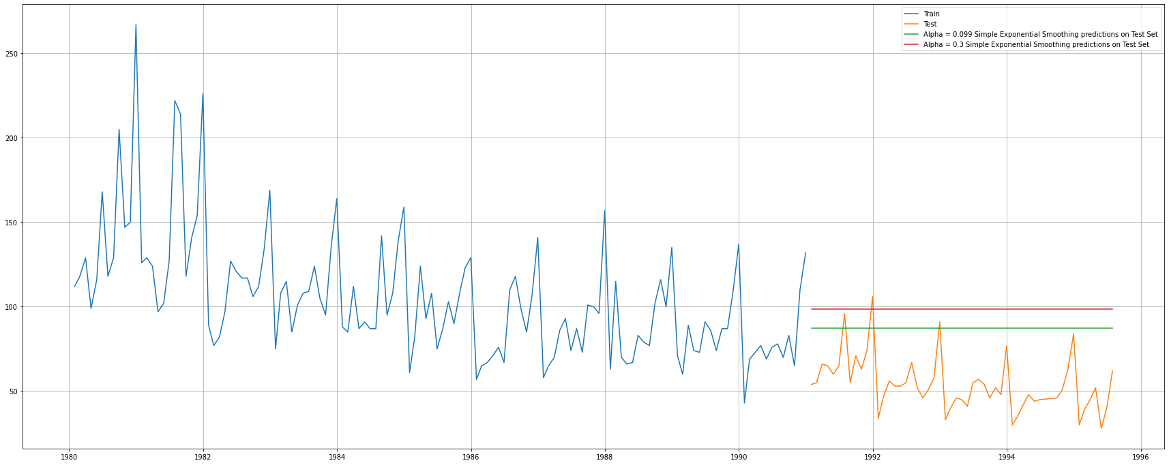

***Figure 4.5(d)***

* *AS OBSERVED, ALPHA = 0.3 IS THE ONE GIVING US THE LOWEST RMSE VALUE.*

## Method 6: Double Exponential Smoothing (Holt's Model)

SPARKLING

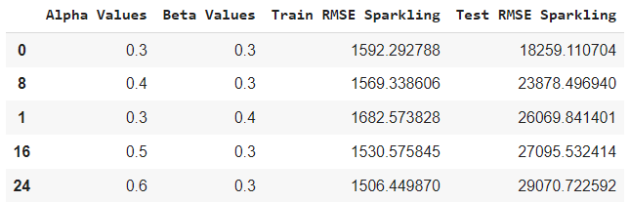

* Here we are getting the lowest RMSE value for alpha=0.3 and beta=0.3.

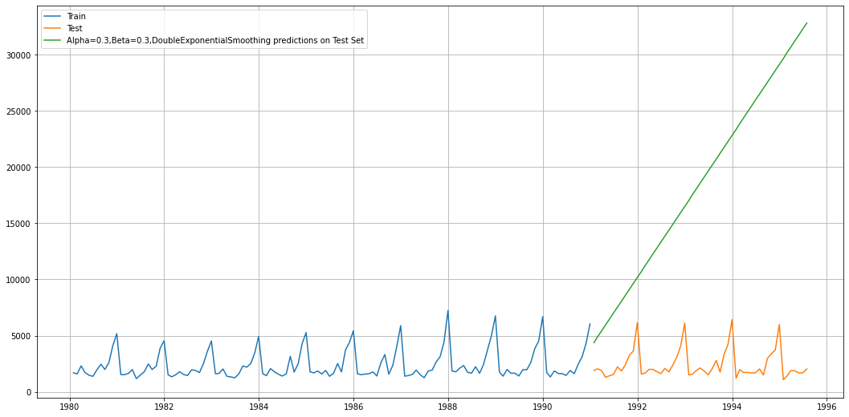

***Figure 4.6(a)***

ROSE

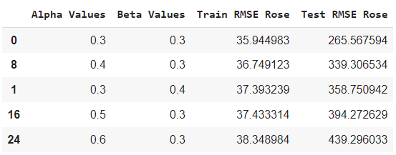

* Here we are getting the lowest RMSE value for alpha=0.3 and beta=0.3.

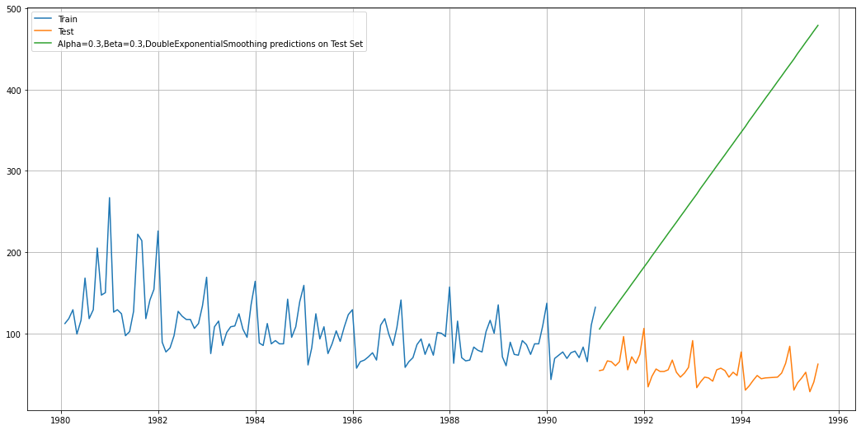

***Figure 4.6(b)***

## Method 7: Triple Exponential Smoothing (Holt - Winter's Model)

Three parameters 𝛼 , 𝛽 and 𝛾 are estimated in this model. Level, Trend and Seasonality are accounted for in this model

SPARKLING

{'damping_slope': nan,

'initial_level': 1639.9993399027126,

'initial_seasons': array([1.00841739, 0.96899632, 1.24171643, 1.13206069, 0.93984119,

0.93813873, 1.22454059, 1.54419134, 1.27332629, 1.63190096,

2.4826116 , 3.11820572]),

'initial_slope': 4.884660841988308,

'lamda': None,

'remove_bias': False,

'smoothing_level': 0.15443784802011637,

'smoothing_seasonal': 0.37116865308973673,

'smoothing_slope': 7.4133171248060435e-28,

'use_boxcox': False}

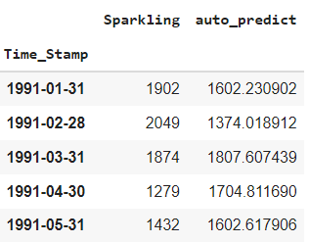

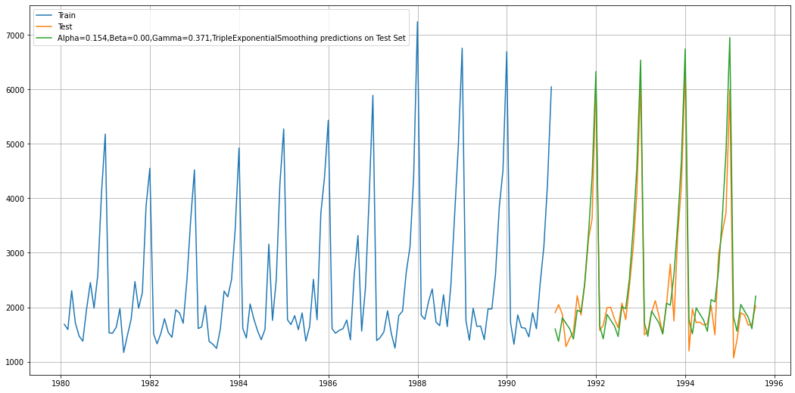

***Figure 4.7(a)***

## Model Evaluation

* For Alpha=0.154,Beta=0.00,Gamma=0.371, Triple Exponential Smoothing Model forecast on the Test Data, RMSE is 384.198

ROSE

{'damping_slope': nan,

'initial_level': 76.65565186546128,

'initial_seasons': array([1.47550231, 1.65927093, 1.80572588, 1.58888782, 1.77822665,

1.92604314, 2.11649409, 2.25135146, 2.11690519, 2.08112772,

2.40927212, 3.30448044]),

'initial_slope': 0.0,

'lamda': None,

'remove_bias': False,

'smoothing_level': 0.10609635974778751,

'smoothing_seasonal': 0.0,

'smoothing_slope': 0.048438458440198374,

'use_boxcox': False}

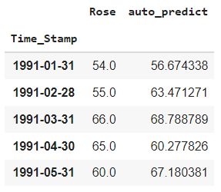

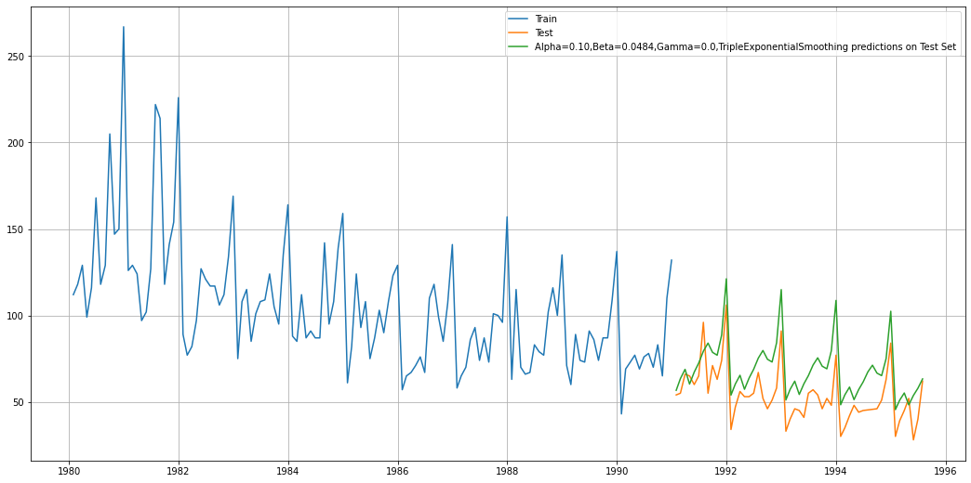

***Figure 4.7(b)***

## Model Evaluation

* For Alpha=0.10,Beta=0.0484,Gamma=0.0, Triple Exponential Smoothing Model forecast on the Test Data, RMSE is 17.369

**Setting different alpha, beta and gamma values.**

**Remember, the higher the alpha value more weightage is given to the more recent observation. That means, what happened recently will happen again.**

**We will run a loop with different alpha values to understand which particular value works best for alpha on the test set.**

SPARKLING

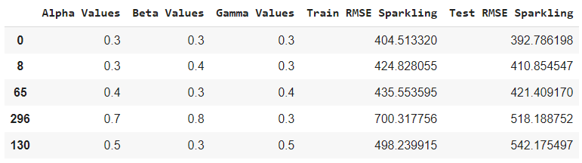

* Here we are getting the lowest RMSE value for alpha=0.3, beta=0.3 and gamma=0.3.

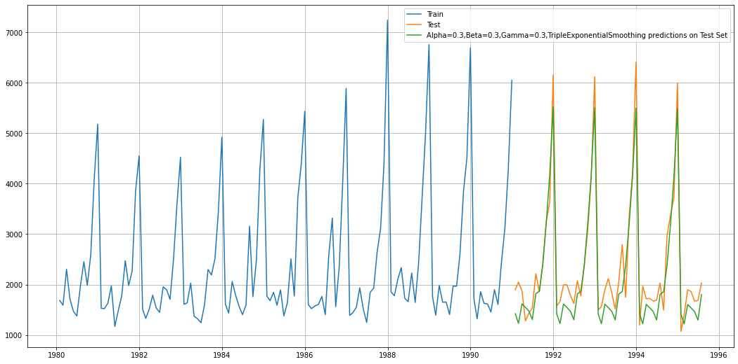

***Figure 4.7(c)***

ROSE

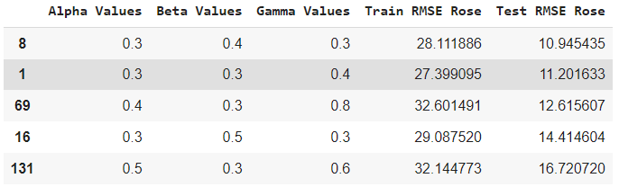

* Here we are getting the lowest RMSE value for alpha=0.3, beta=0.4 and gamma=0.3.

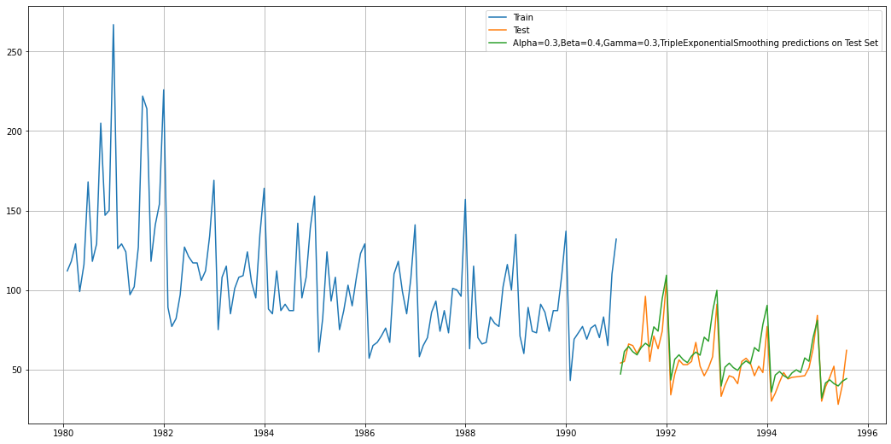

***Figure 4.7(d)***

## 5. Check for the stationarity of the data on which the model is being built on using appropriate statistical tests and also mention the hypothesis for the statistical test. If the data is found to be non-stationary, take appropriate steps to make it stationary. Check the new data for stationarity and comment. Note: Stationarity should be checked at alpha = 0.05.

SPARKLING

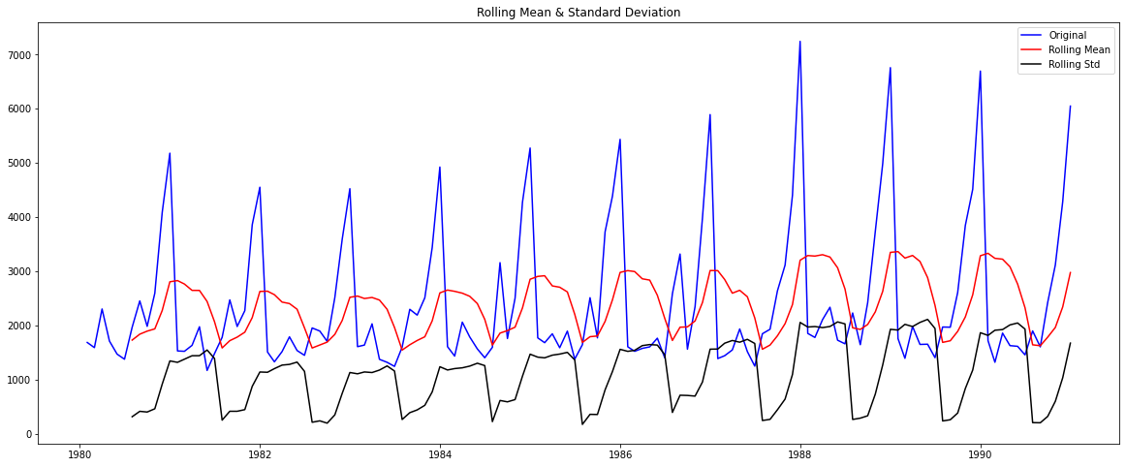

***Figure 5.1(a)***

Results of Dickey-Fuller Test:

Test Statistic -1.208926

p-value 0.669744

#Lags Used 12.000000

Number of Observations Used 119.000000

Critical Value (1%) -3.486535

Critical Value (5%) -2.886151

Critical Value (10%) -2.579896

* **We see that the series is not stationary at 𝛼 = 0.05. Since p-value > 0.05**

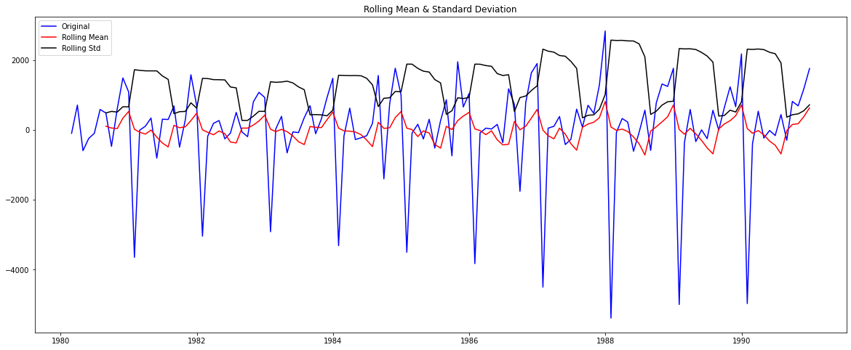

***Figure 5.1(b)***

Results of Dickey-Fuller Test:

Test Statistic -8.005007e+00

p-value 2.280104e-12

#Lags Used 1.100000e+01

Number of Observations Used 1.190000e+02

Critical Value (1%) -3.486535e+00

Critical Value (5%) -2.886151e+00

Critical Value (10%) -2.579896e+00

* **We see that after taking a difference of order 1 the series have become stationary at 𝛼 = 0.05.**
* **Since p-value < 0.05**

**Note: If the series is non-stationary, stationarize the Time Series by taking a difference of the Time Series. Then we can use this particular differenced series to train the ARIMA models. We do not need to worry about stationarity for the Test Data because we are not building any models on the Test Data, we are evaluating our models over there. You can look at other kinds of transformations as part of making the time series stationary like taking logarithms.**

ROSE

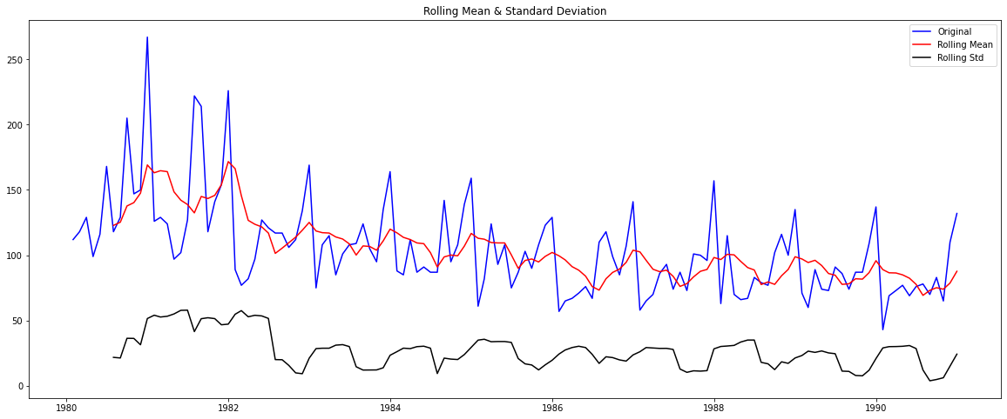

***Figure 5.2(a)***

Results of Dickey-Fuller Test:

Test Statistic -2.164250

p-value 0.219476

#Lags Used 13.000000

Number of Observations Used 118.000000

Critical Value (1%) -3.487022

Critical Value (5%) -2.886363

Critical Value (10%) -2.580009

* **We see that the series is not stationary at 𝛼 = 0.05. Since p-value > 0.05**

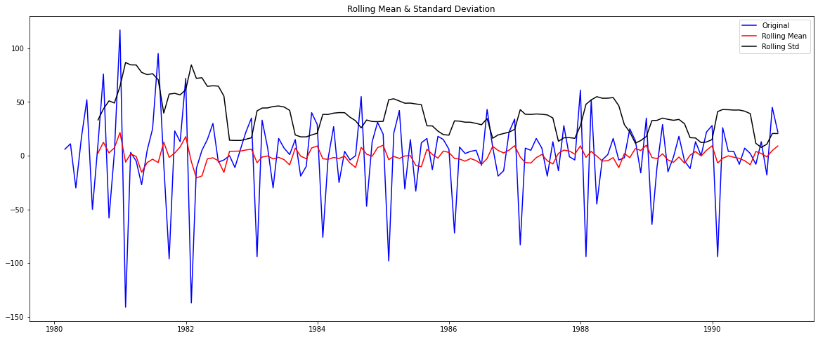

***Figure 5.2(b)***

Results of Dickey-Fuller Test:

Test Statistic -6.592372e+00

p-value 7.061944e-09

#Lags Used 1.200000e+01

Number of Observations Used 1.180000e+02

Critical Value (1%) -3.487022e+00

Critical Value (5%) -2.886363e+00

Critical Value (10%) -2.580009e+00

* **We see that after taking a difference of order 1 the series have become stationary at 𝛼 = 0.05.**
* **Since p-value < 0.05**

## 6. Build an automated version of the ARIMA/SARIMA model in which the parameters are selected using the lowest Akaike Information Criteria (AIC) on the training data and evaluate this model on the test data using RMSE.

* ARIMA

SPARKLING

Some parameter combinations for the Model...

Model: (0, 1, 1)

Model: (0, 1, 2)

Model: (1, 1, 0)

Model: (1, 1, 1)

Model: (1, 1, 2)

Model: (2, 1, 0)

Model: (2, 1, 1)

Model: (2, 1, 2)

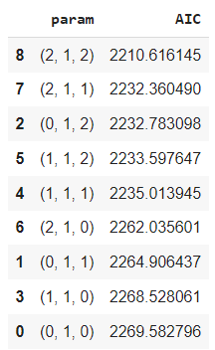 WE will choose the lowest AIC value for best results, here (2,1,2)

ARIMA Model Results

==============================================================================

Dep. Variable: D.Sparkling No. Observations: 131

Model: ARIMA(2, 1, 2) Log Likelihood -1099.308

Method: css-mle S.D. of innovations 1012.081

Date: Tue, 10 Aug 2021 AIC 2210.616

Time: 11:28:38 BIC 2227.867

Sample: 02-29-1980 HQIC 2217.626

- 12-31-1990

=====================================================================================

coef std err z P>|z| [0.025 0.975]

-------------------------------------------------------------------------------------

const 5.5859 0.516 10.826 0.000 4.575 6.597

ar.L1.D.Sparkling 1.2699 0.074 17.047 0.000 1.124 1.416

ar.L2.D.Sparkling -0.5601 0.074 -7.617 0.000 -0.704 -0.416

ma.L1.D.Sparkling -1.9991 0.042 -47.175 0.000 -2.082 -1.916

ma.L2.D.Sparkling 0.9991 0.042 23.591 0.000 0.916 1.082

Roots

=============================================================================

Real Imaginary Modulus Frequency

-----------------------------------------------------------------------------

AR.1 1.1336 -0.7073j 1.3361 -0.0888

AR.2 1.1336 +0.7073j 1.3361 0.0888

MA.1 1.0005 -0.0009j 1.0005 -0.0001

MA.2 1.0005 +0.0009j 1.0005 0.0001

-----------------------------------------------------------------------------

/usr/local/lib/python3.7/dist-packages/statsmodels/base/model.py:492: HessianInversionWarning: Inverting hessian failed, no bse or cov_params available

'available', HessianInversionWarning)

## Predict on the Test Set using this model and evaluate the model.

forecast Returns

forecast : array Array of out of sample forecasts

stderr : array Array of the standard error of the forecasts.

conf_int : array 2d array of the confidence interval for the forecast

* The RMSE value for ARIMA(2,1,2) is 1374.976339330213

ROSE

* Some parameter combinations for the Model...
* Model: (0, 1, 1)
* Model: (0, 1, 2)
* Model: (1, 1, 0)
* Model: (1, 1, 1)
* Model: (1, 1, 2)
* Model: (2, 1, 0)
* Model: (2, 1, 1)
* Model: (2, 1, 2)

## WE will choose the lowest AIC value for best results, here (0,1,2)

ARIMA Model Results

==============================================================================

Dep. Variable: D.Rose No. Observations: 131

Model: ARIMA(0, 1, 2) Log Likelihood -634.418

Method: css-mle S.D. of innovations 30.167

Date: Tue, 10 Aug 2021 AIC 1276.835

Time: 11:28:39 BIC 1288.336

Sample: 02-29-1980 HQIC 1281.509

- 12-31-1990

================================================================================

coef std err z P>|z| [0.025 0.975]

--------------------------------------------------------------------------------

const -0.4885 0.085 -5.742 0.000 -0.655 -0.322

ma.L1.D.Rose -0.7601 0.101 -7.499 0.000 -0.959 -0.561

ma.L2.D.Rose -0.2398 0.095 -2.518 0.013 -0.427 -0.053

Roots

=============================================================================

Real Imaginary Modulus Frequency

-----------------------------------------------------------------------------

MA.1 1.0001 +0.0000j 1.0001 0.0000

MA.2 -4.1696 +0.0000j 4.1696 0.5000

-----------------------------------------------------------------------------

## Predict on the Test Set using this model and evaluate the model.

* The RMSE value for ARIMA(0,1,2) is 15.618703067489148
* SARIMA

SPARKLING

Let us look at the ACF plot once more to understand the seasonal parameter for the SARIMA model.



***Figure 6.1(a)***

We see that there can be a seasonality of 6 as well as 12. We will run our auto SARIMA models by setting seasonality both as 6 and 12.

* Setting the seasonality as 6 for the first iteration of the auto SARIMA model.

Top 5 Results sorted by AIC values.

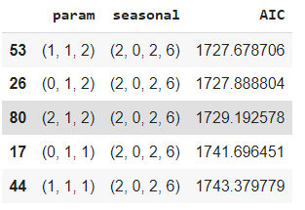

Statespace Model Results

=======================================================================================

Dep. Variable: y No. Observations: 132

Model: SARIMAX(1, 1, 2)x(2, 0, 2, 6) Log Likelihood 855.839

Date: Tue, 10 Aug 2021 AIC 1727.679

Time: 11:29:13 BIC 1749.707

Sample: 0 HQIC 1736.621

- 132

Covariance Type: opg

==============================================================================

coef std err z P>|z| [0.025 0.975]

------------------------------------------------------------------------------

ar.L1 -0.6452 0.286 -2.258 0.024 -1.205 -0.085

ma.L1 -0.1065 0.250 -0.427 0.670 -0.596 0.383

ma.L2 -0.7008 0.202 -3.474 0.001 -1.096 -0.305

ar.S.L6 -0.0045 0.027 -0.165 0.869 -0.057 0.049

ar.S.L12 1.0361 0.018 56.097 0.000 1.000 1.072

ma.S.L6 0.0675 0.152 0.444 0.657 -0.231 0.366

ma.S.L12 -0.6125 0.093 -6.591 0.000 -0.795 -0.430

sigma2 1.448e+05 1.71e+04 8.466 0.000 1.11e+05 1.78e+05

===================================================================================

Ljung-Box (Q): 28.93 Jarque-Bera (JB): 25.23

Prob(Q): 0.90 Prob(JB): 0.00

Heteroskedasticity (H): 2.63 Skew: 0.47

Prob(H) (two-sided): 0.00 Kurtosis: 5.09

Warnings:

[1] Covariance matrix calculated using the outer product of gradients (complex-step).

DIAGNOSTIC PLOT

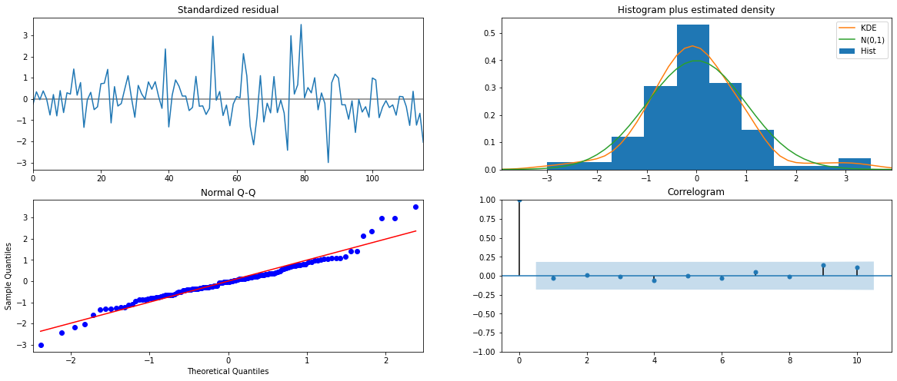

***Figure 6.1(b)***

From the model diagnostics plot, we can see that all the individual diagnostics plots almost follow the theoretical numbers and thus we cannot develop any pattern from these plots.

Predict on the Test Set using this model and evaluate the model.

Summary Frame of the model.

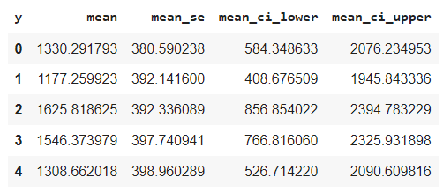

## Predict on the Test Set using this model and evaluate the model.

* The RMSE value for SARIMA(1,1,2)(2,0,2,6) is 626.933219231813

**ROSE**



***Figure 6.2(a)***

* Setting the seasonality as 6 for the first iteration of the auto SARIMA model.

Top 5 Results sorted by AIC values.

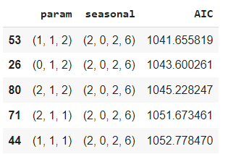

Statespace Model Results

=======================================================================================

Dep. Variable: y No. Observations: 132

Model: SARIMAX(1, 1, 2)x(2, 0, 2, 6) Log Likelihood 512.828

Date: Wed, 11 Aug 2021 AIC 1041.656

Time: 14:28:36 BIC 1063.685

Sample: 0 HQIC 1050.598

- 132

Covariance Type: opg

==============================================================================

coef std err z P>|z| [0.025 0.975]

------------------------------------------------------------------------------

ar.L1 -0.5938 0.152 -3.896 0.000 -0.892 -0.295

ma.L1 -0.1955 964.803 -0.000 1.000 -1891.175 1890.784

ma.L2 -0.8045 776.176 -0.001 0.999 -1522.082 1520.473

ar.S.L6 -0.0626 0.035 -1.765 0.078 -0.132 0.007

ar.S.L12 0.8451 0.039 21.886 0.000 0.769 0.921

ma.S.L6 0.2226 311.195 0.001 0.999 -609.708 610.153

ma.S.L12 -0.7775 241.893 -0.003 0.997 -474.879 473.324

sigma2 335.2008 3.49e+05 0.001 0.999 -6.83e+05 6.84e+05

===================================================================================

Ljung-Box (Q): 15.89 Jarque-Bera (JB): 56.68

Prob(Q): 1.00 Prob(JB): 0.00

Heteroskedasticity (H): 0.47 Skew: 0.52

Prob(H) (two-sided): 0.02 Kurtosis: 6.26

===================================================================================

Warnings:

[1] Covariance matrix calculated using the outer product of gradients (complex-step).

DIAGNOSTIC PLOT

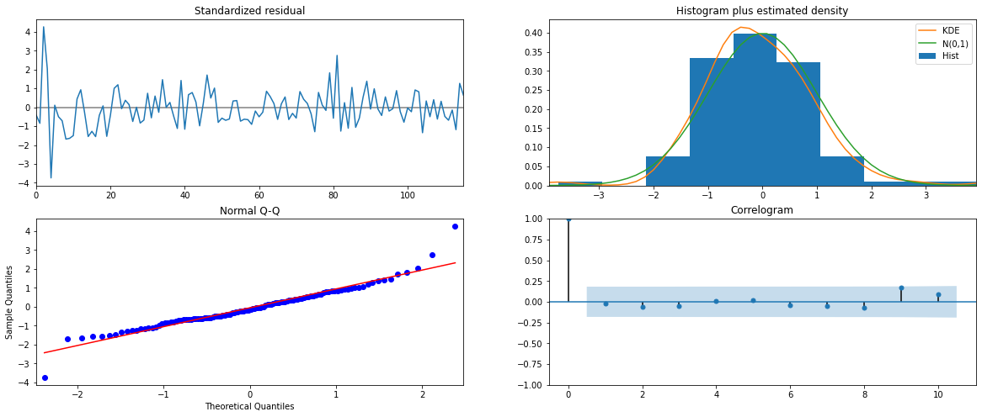

***Figure 6.2(b)***

From the model diagnostics plot, we can see that all the individual diagnostics plots almost follow the theoretical numbers and thus we cannot develop any pattern from these plots.

## Predict on the Test Set using this model and evaluate the model.

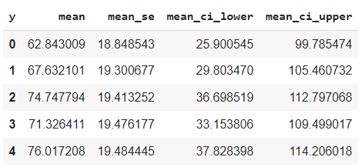

* + The RMSE value for SARIMA(1,1,2)(2,0,2,6) is 26.136428629473784

## Setting the seasonality as 12 for the second iteration of the auto SARIMA model.

Top 5 Results sorted by AIC values for SPARKLING.

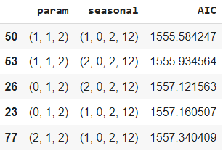

Statespace Model Results

======================================================================================

Dep. Variable: y No. Observations: 132

Model: SARIMAX(1, 1, 2)x(1, 0, 2, 12) Log Likelihood 770.792

Date: Wed, 11 Aug 2021 AIC 1555.584

Time: 14:29:59 BIC 1574.095

Sample: 0 HQIC 1563.083

- 132

Covariance Type: opg

==============================================================================

coef std err z P>|z| [0.025 0.975]

------------------------------------------------------------------------------

ar.L1 -0.6282 0.255 -2.464 0.014 -1.128 -0.128

ma.L1 -0.1040 0.225 -0.463 0.643 -0.545 0.336

ma.L2 -0.7277 0.154 -4.736 0.000 -1.029 -0.427

ar.S.L12 1.0439 0.014 72.837 0.000 1.016 1.072

ma.S.L12 -0.5550 0.098 -5.663 0.000 -0.747 -0.363

ma.S.L24 -0.1354 0.120 -1.133 0.257 -0.370 0.099

sigma2 1.506e+05 2.03e+04 7.401 0.000 1.11e+05 1.9e+05

===================================================================================

Ljung-Box (Q): 23.02 Jarque-Bera (JB): 11.72

Prob(Q): 0.99 Prob(JB): 0.00

Heteroskedasticity (H): 1.47 Skew: 0.36

Prob(H) (two-sided): 0.26 Kurtosis: 4.48

Diagnostic Plot

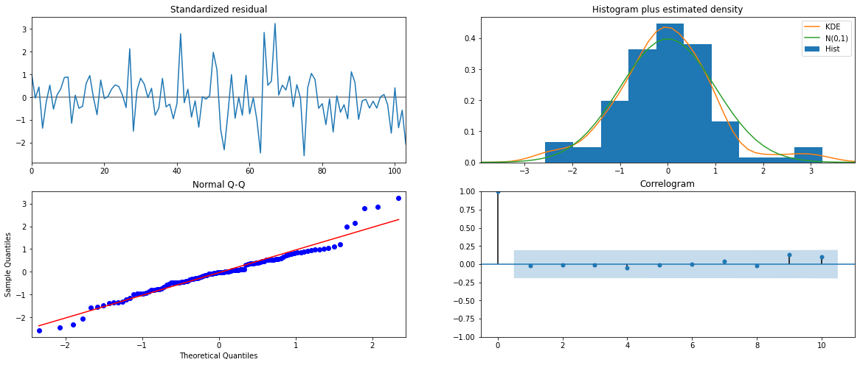

***Figure 6.3(a)***

Similar to the last iteration of the model where the seasonality parameter was taken as 6, here also we see that the model diagnostics plot does not indicate any remaining information that we can get.

## Predict on the Test Set using this model and evaluate the model.

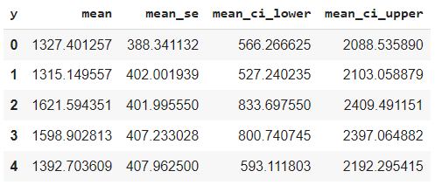

* The RMSE value for SARIMA(1,1,2)(1,0,2,12) is 528.6025130673597

Top 5 Results sorted by AIC values for ROSE.

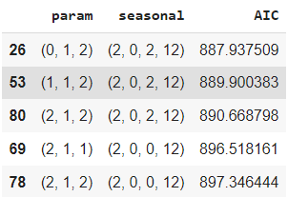

Statespace Model Results

=======================================================================================

Dep. Variable: y No. Observations: 132

Model: SARIMAX(0, 1, 2)x(2, 0, 2, 12) Log Likelihood 436.969

Date: Wed, 11 Aug 2021 AIC 887.938

Time: 14:30:57 BIC 906.448

Sample: 0 HQIC 895.437

- 132

Covariance Type: opg

==============================================================================

coef std err z P>|z| [0.025 0.975]

------------------------------------------------------------------------------

ma.L1 -0.8427 189.890 -0.004 0.996 -373.020 371.334

ma.L2 -0.1573 29.833 -0.005 0.996 -58.628 58.314

ar.S.L12 0.3467 0.079 4.375 0.000 0.191 0.502

ar.S.L24 0.3023 0.076 3.996 0.000 0.154 0.451

ma.S.L12 0.0767 0.133 0.577 0.564 -0.184 0.337

ma.S.L24 -0.0726 0.146 -0.498 0.618 -0.358 0.213

sigma2 251.3137 4.77e+04 0.005 0.996 -9.33e+04 9.38e+04

===================================================================================

Ljung-Box (Q): 24.56 Jarque-Bera (JB): 2.33

Prob(Q): 0.97 Prob(JB): 0.31

Heteroskedasticity (H): 0.88 Skew: 0.37

Prob(H) (two-sided): 0.70 Kurtosis: 3.03

===================================================================================

Warnings:

[1] Covariance matrix calculated using the outer product of gradients (complex-step).

Diagnostic Plot

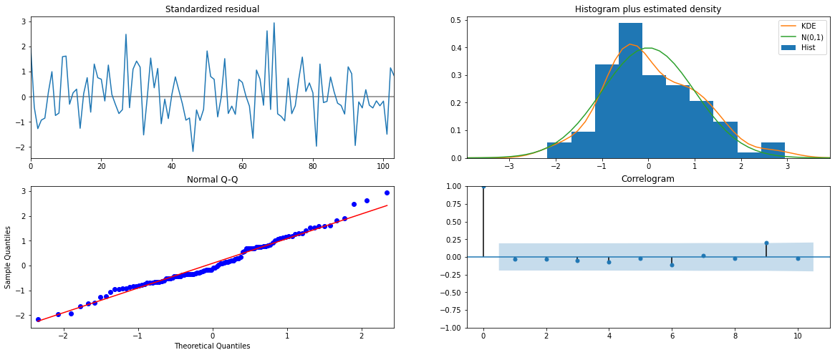

***Figure 6.3(b)***

Similar to the last iteration of the model where the seasonality parameter was taken as 6, here also we see that the model diagnostics plot does not indicate any remaining information that we can get.

## Predict on the Test Set using this model and evaluate the model.

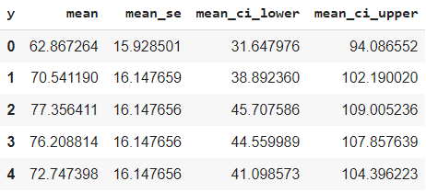

* The RMSE value for SARIMA(0,1,2)(2,0,2,12) is 26.928361908025416

## 7. Build ARIMA/SARIMA models based on the cut-off points of ACF and PACF on the training data and evaluate this model on the test data using RMSE.

SPARKLING

* ARIMA

Here we will be using the differenced time series dataset .





***Figure 7.1(a)***

Here, we have taken alpha=0.05.

The Auto-Regressive parameter in an ARIMA model is 'p' which comes from the significant lag before which the PACF plot cuts-off to 3.

The Moving-Average parameter in an ARIMA model is 'q' which comes from the significant lag before the ACF plot cuts-off to 2.

ARIMA Model Results

==============================================================================

Dep. Variable: D.Sparkling No. Observations: 131

Model: ARIMA(3, 1, 2) Log Likelihood -1107.464

Method: css-mle S.D. of innovations 1106.180

Date: Wed, 11 Aug 2021 AIC 2228.928

Time: 14:30:59 BIC 2249.054

Sample: 02-29-1980 HQIC 2237.106

- 12-31-1990

=====================================================================================

coef std err z P>|z| [0.025 0.975]

-------------------------------------------------------------------------------------

const 5.9886 3.644 1.643 0.103 -1.154 13.131

ar.L1.D.Sparkling -0.4420 8.18e-06 -5.41e+04 0.000 -0.442 -0.442

ar.L2.D.Sparkling 0.3081 2.58e-05 1.19e+04 0.000 0.308 0.308

ar.L3.D.Sparkling -0.2499 2.2e-05 -1.13e+04 0.000 -0.250 -0.250

ma.L1.D.Sparkling -0.0007 0.020 -0.034 0.973 -0.040 0.038

ma.L2.D.Sparkling -0.9993 0.020 -50.450 0.000 -1.038 -0.961

Roots

=============================================================================

Real Imaginary Modulus Frequency

-----------------------------------------------------------------------------

AR.1 -1.0000 -0.0000j 1.0000 -0.5000

AR.2 1.1165 -1.6600j 2.0005 -0.1558

AR.3 1.1165 +1.6600j 2.0005 0.1558

MA.1 1.0000 +0.0000j 1.0000 0.0000

MA.2 -1.0007 +0.0000j 1.0007 0.5000

-----------------------------------------------------------------------------

## Predict on the Test Set using this model and evaluate the model.

* The RMSE value for ARIMA (3,1,2) is 1379.1826761518028

ROSE



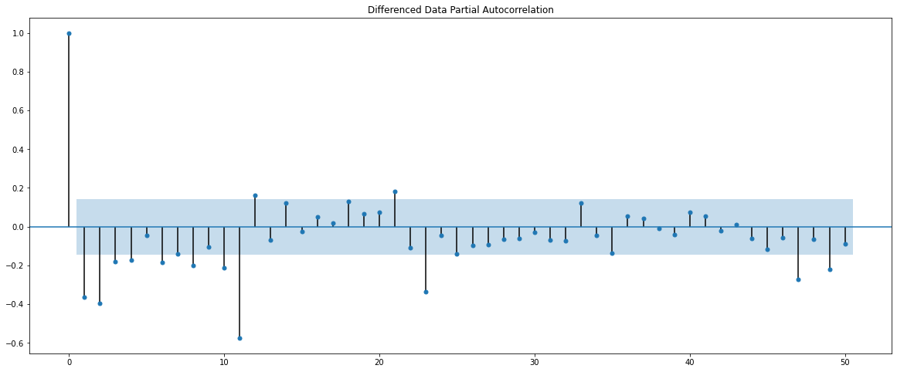

***Figure 7.1(b)***

Here, we have taken alpha=0.05.

The Auto-Regressive parameter in an ARIMA model is 'p' which comes from the significant lag before which the PACF plot cuts-off to 4. But we will take its value as 3 to prevent a complex model.

The Moving-Average parameter in an ARIMA model is 'q' which comes from the significant lag before the ACF plot cuts-off to 2.

ARIMA Model Results

==============================================================================

Dep. Variable: D.Rose No. Observations: 131

Model: ARIMA(3, 1, 2) Log Likelihood -633.485

Method: css-mle S.D. of innovations 29.950

Date: Thu, 12 Aug 2021 AIC 1280.969

Time: 11:02:14 BIC 1301.096

Sample: 02-29-1980 HQIC 1289.148

- 12-31-1990

================================================================================

coef std err z P>|z| [0.025 0.975]

--------------------------------------------------------------------------------

const -0.4883 0.085 -5.723 0.000 -0.656 -0.321

ar.L1.D.Rose -0.3558 0.332 -1.071 0.286 -1.007 0.296

ar.L2.D.Rose 0.0279 0.120 0.232 0.817 -0.208 0.264

ar.L3.D.Rose 0.0598 0.104 0.577 0.565 -0.143 0.263

ma.L1.D.Rose -0.4141 0.325 -1.274 0.205 -1.051 0.223

ma.L2.D.Rose -0.5857 0.324 -1.810 0.073 -1.220 0.049

Roots

=============================================================================

Real Imaginary Modulus Frequency

-----------------------------------------------------------------------------

AR.1 -1.8009 -1.4473j 2.3104 -0.3923

AR.2 -1.8009 +1.4473j 2.3104 0.3923

AR.3 3.1348 -0.0000j 3.1348 -0.0000

MA.1 1.0001 +0.0000j 1.0001 0.0000

MA.2 -1.7072 +0.0000j 1.7072 0.5000

-----------------------------------------------------------------------------

## Predict on the Test Set using this model and evaluate the model.

* The RMSE value for ARIMA (3,1,2) is 15.52288708797049
* SARIMA

SPARKLING

Let us look at the ACF and the PACF plots once more.





***Figure 7.2(a)***

We see that our ACF plot at the seasonal interval (6) does begin to taper off.



***Figure 7.2(b)***

* Seasonality = 6

We see that there is a little trend and seasonality. So, now we take a seasonal differencing and check the series.

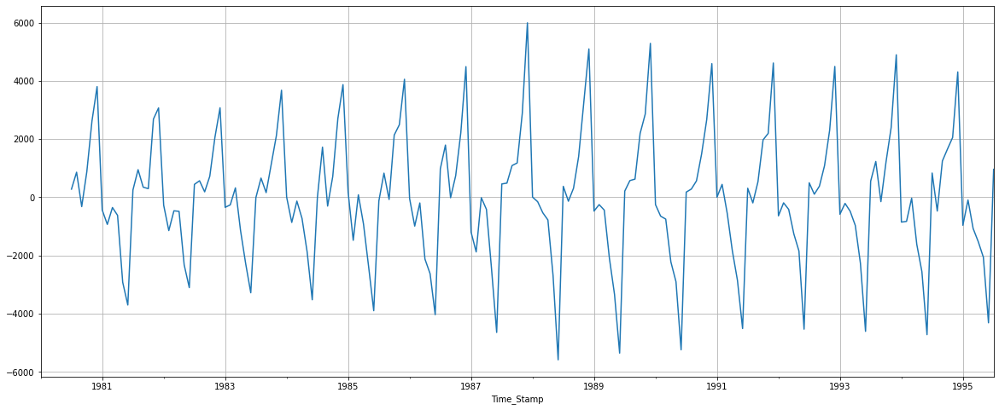

***Figure 7.2(c)***

Now we see that there is almost no trend present in the data. Seasonality is only present in the data.

Let us go ahead and check the stationarity of the above series before fitting the SARIMA model.

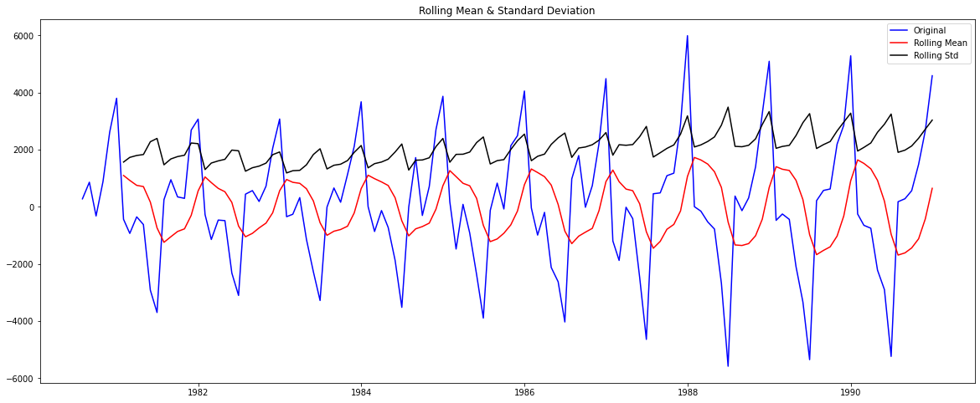

***Figure 7.2(d)***

**Results of Dickey-Fuller Test:**

**Test Statistic -8.181919e+00**

**p-value 8.088278e-13**

**#Lags Used 6.000000e+00**

**Number of Observations Used 1.190000e+02**

**Critical Value (1%) -3.486535e+00**

**Critical Value (5%) -2.886151e+00**

**Critical Value (10%) -2.579896e+00**

**As observed we have a p-value lesser than our alpha 0.05. This explains that our time series is stationary therefore we won’t difference it further.**

Checking the ACF and the PACF plots for the new modified Time Series

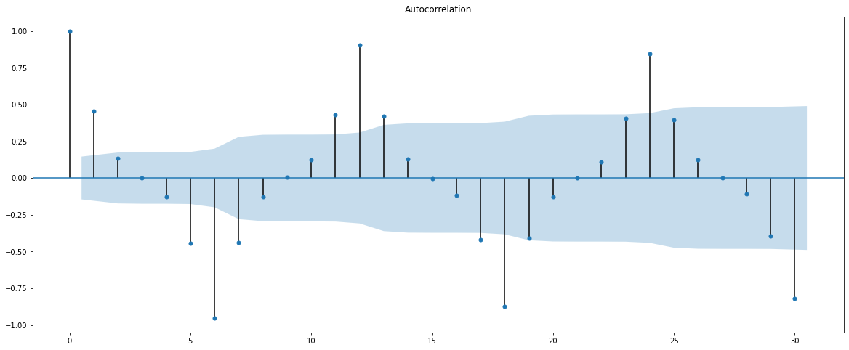

**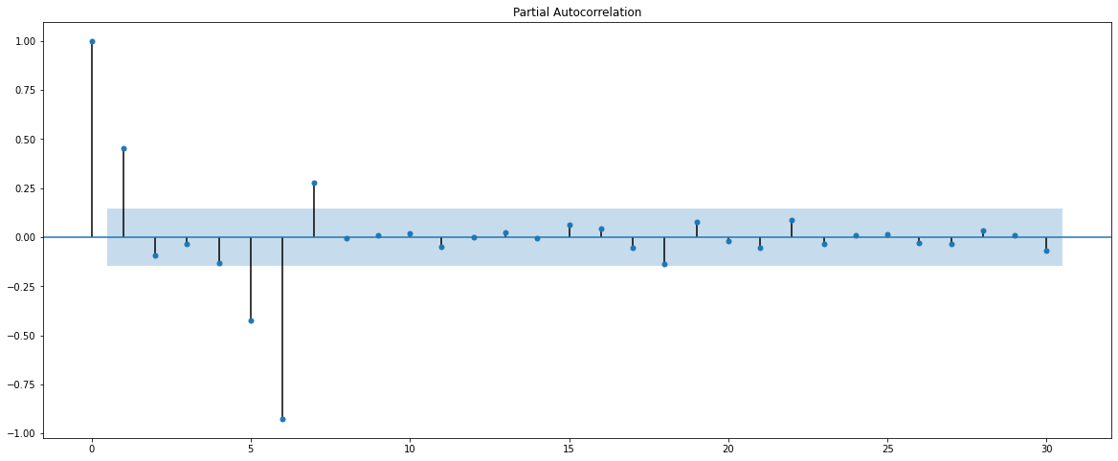 *Figure 7.2(e)***

Here, we have taken alpha=0.05.

We are going to take the seasonal period as 6.

The Auto-Regressive parameter in an SARIMA model is 'P' which comes from the significant lag after which the PACF plot cuts-off to 1.

The Moving-Average parameter in an SARIMA model is 'Q' which comes from the significant lag after which the ACF plot cuts-off to 3 to prevent model complexity.

Remember to check the ACF and the PACF plots only at multiples of 6 (since 6 is the seasonal period).

Statespace Model Results

======================================================================================

Dep. Variable: y No. Observations: 132

Model: SARIMAX(3, 1, 2)x(1, 0, 3, 6) Log Likelihood 845.298

Date: Thu, 12 Aug 2021 AIC 1710.596

Time: 11:48:59 BIC 1737.601

Sample: 0 HQIC 1721.549

- 132

Covariance Type: opg

==============================================================================

coef std err z P>|z| [0.025 0.975]

------------------------------------------------------------------------------

ar.L1 -0.6986 0.105 -6.664 0.000 -0.904 -0.493

ar.L2 -0.0459 0.129 -0.357 0.721 -0.298 0.206

ar.L3 -0.3418 0.091 -3.737 0.000 -0.521 -0.163

ma.L1 0.0326 1.722 0.019 0.985 -3.342 3.407

ma.L2 -0.9675 1.655 -0.584 0.559 -4.212 2.277

ar.S.L6 -1.0288 0.010 -104.687 0.000 -1.048 -1.010

ma.S.L6 1.3230 1.691 0.783 0.434 -1.991 4.637

ma.S.L12 0.8141 0.587 1.386 0.166 -0.337 1.965

ma.S.L18 0.4979 0.809 0.616 0.538 -1.087 2.083

sigma2 2.404e+05 1.36e-05 1.77e+10 0.000 2.4e+05 2.4e+05

===================================================================================

Ljung-Box (Q): 110.87 Jarque-Bera (JB): 4.27

Prob(Q): 0.00 Prob(JB): 0.12

Heteroskedasticity (H): 2.21 Skew: 0.38

Prob(H) (two-sided): 0.02 Kurtosis: 3.58

===================================================================================

Warnings:

[1] Covariance matrix calculated using the outer product of gradients (complex-step).

Diagnostic Plot

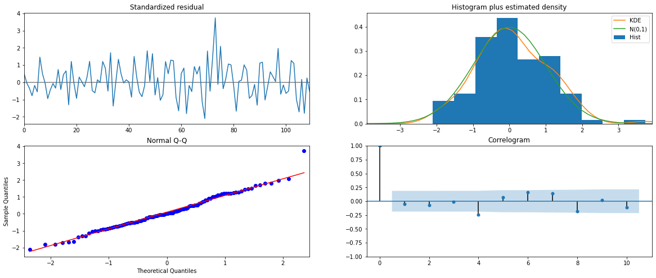

***Figure 7.2(f)***

From the model diagnostics plot, we can see that all the individual diagnostics plots almost follow the theoretical numbers and thus we cannot develop any pattern from these plots.

## Predict on the Test Set using this model and evaluate the model.

DATA SUMMARY

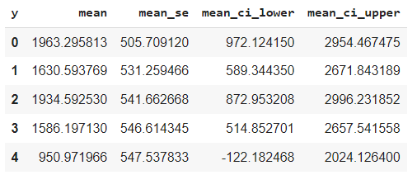

* The RMSE value for ARIMA (3,1,2) is 902.7907259447834
* Seasonality = 12

We see that there is a little trend and seasonality. So, now we take a seasonal differencing and check the series.

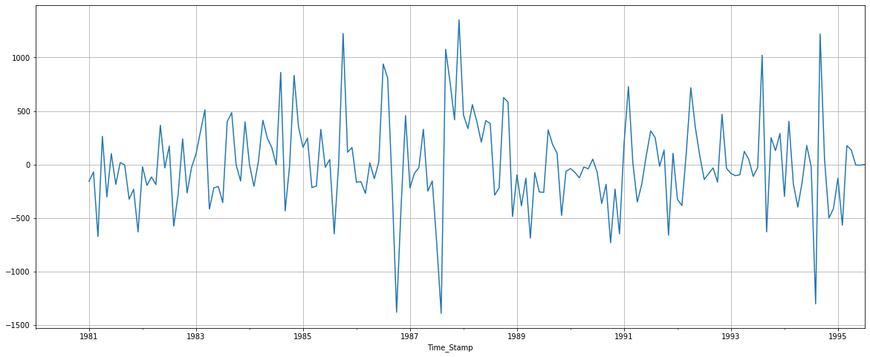

***Figure 7.3(a)***

Now we see that there is almost no trend present in the data. Seasonality is only present in the data.

Let us go ahead and check the stationarity of the above series before fitting the SARIMA model.

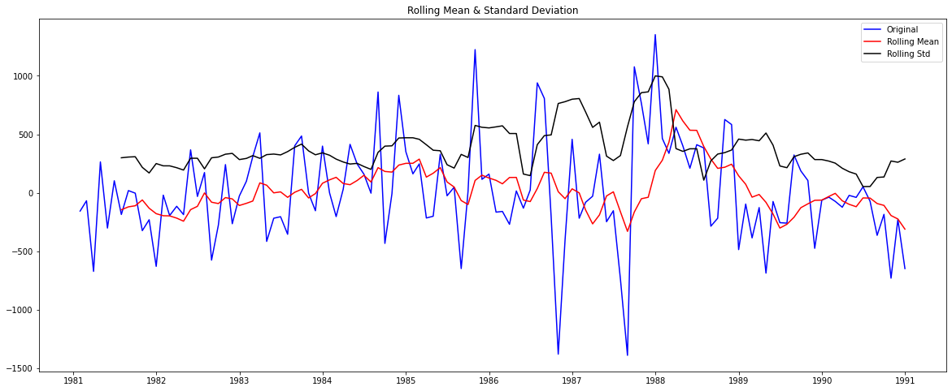

***Figure 7.3(b)***

**Results of Dickey-Fuller Test:**

**Test Statistic -3.136812**

**p-value 0.023946**

**#Lags Used 11.000000**

**Number of Observations Used 108.000000**

**Critical Value (1%) -3.492401**

**Critical Value (5%) -2.888697**

**Critical Value (10%) -2.581255**

**dtype: float64**

**As observed we have a p-value lesser than our alpha 0.05. This explains that our time series is stationary therefore we won’t difference it further.**

Checking the ACF and the PACF plots for the new modified Time Series

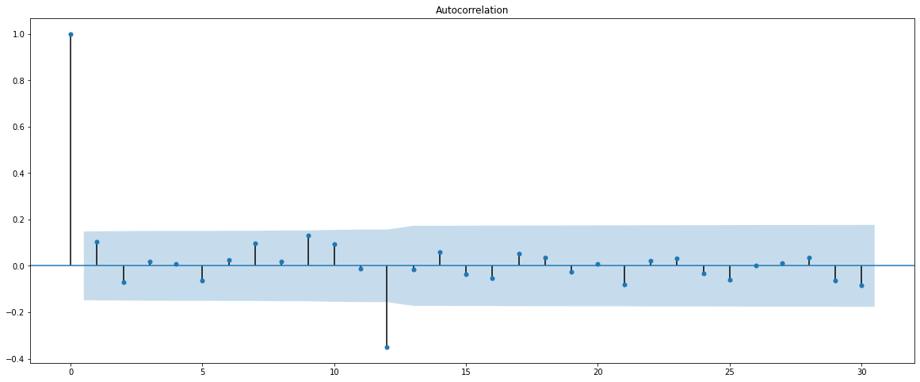

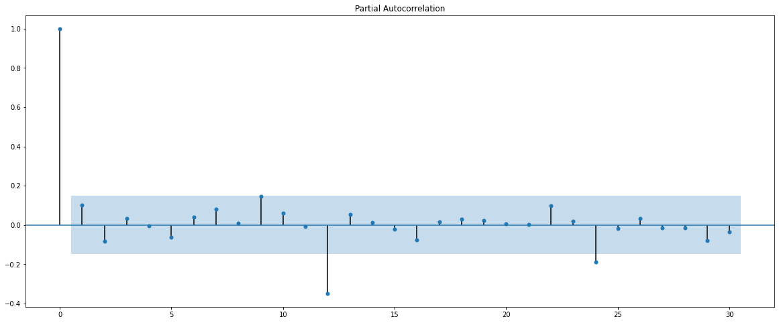

***Figure 7.3(c)***

Here, we have taken alpha=0.05.

We are going to take the seasonal period as 12.

The Auto-Regressive parameter in an SARIMA model is 'P' which comes from the significant lag after which the PACF plot cuts-off to 2.

The Moving-Average parameter in an SARIMA model is 'Q' which comes from the significant lag after which the ACF plot cuts-off to 1.

Remember to check the ACF and the PACF plots only at multiples of 12 (since 12 is the seasonal period).

Statespace Model Results

=======================================================================================

Dep. Variable: y No. Observations: 132

Model: SARIMAX(3, 1, 2)x(2, 0, 1, 12) Log Likelihood 771.395

Date: Thu, 12 Aug 2021 AIC 1560.790

Time: 12:32:45 BIC 1584.589

Sample: 0 HQIC 1570.432

- 132

Covariance Type: opg

==============================================================================

coef std err z P>|z| [0.025 0.975]

------------------------------------------------------------------------------

ar.L1 -0.6518 0.313 -2.081 0.037 -1.266 -0.038

ar.L2 -0.0463 0.178 -0.260 0.795 -0.396 0.303

ar.L3 0.0172 0.134 0.129 0.898 -0.245 0.279

ma.L1 -0.3499 0.244 -1.432 0.152 -0.829 0.129

ma.L2 -0.8706 0.331 -2.633 0.008 -1.519 -0.223

ar.S.L12 1.0340 0.226 4.578 0.000 0.591 1.477

ar.S.L24 0.0067 0.226 0.030 0.976 -0.436 0.450

ma.S.L12 -0.5825 0.229 -2.546 0.011 -1.031 -0.134

sigma2 1.228e+05 2.58e+04 4.761 0.000 7.22e+04 1.73e+05

===================================================================================

Ljung-Box (Q): 24.26 Jarque-Bera (JB): 11.01

Prob(Q): 0.98 Prob(JB): 0.00

Heteroskedasticity (H): 1.53 Skew: 0.33

Prob(H) (two-sided): 0.22 Kurtosis: 4.45

===================================================================================

Diagnostic Plot

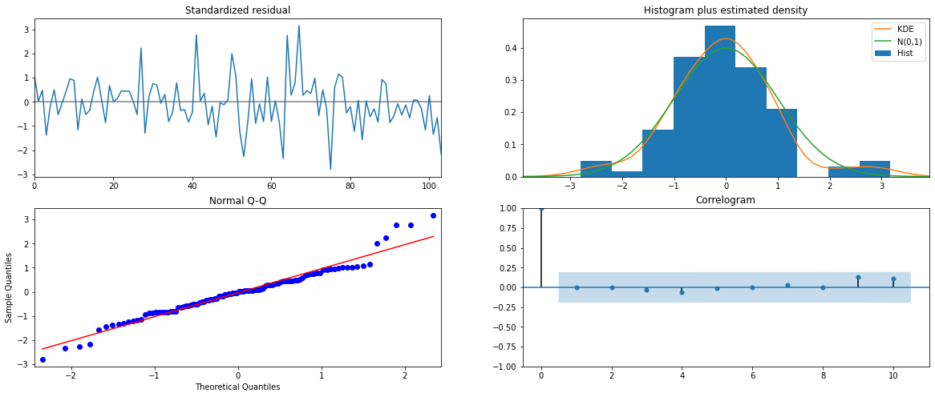

***Figure 7.3(d)***

From the model diagnostics plot, we can see that all the individual diagnostics plots almost follow the theoretical numbers and thus we cannot develop any pattern from these plots.

## Predict on the Test Set using this model and evaluate the model.

DATA SUMMARY

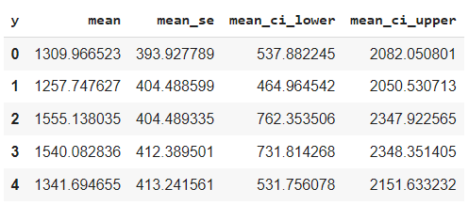

* The RMSE value for ARIMA (3,1,2) is 611.0380372403605

**ROSE**





***Figure 7.4(a)***

We see that our ACF plot at the seasonal interval (6) does begin to taper off.

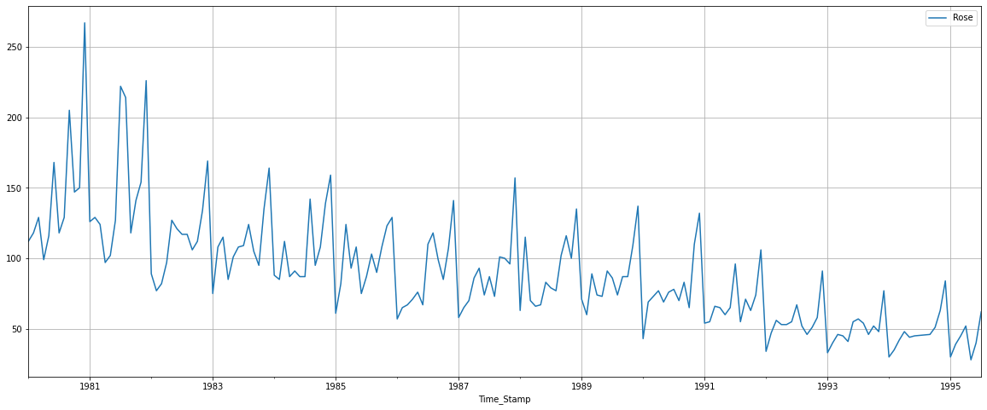

***Figure 7.4(b)***

* Seasonality = 6

We see that there is a downward trend and seasonality. So, now we take a seasonal differencing and check the series.

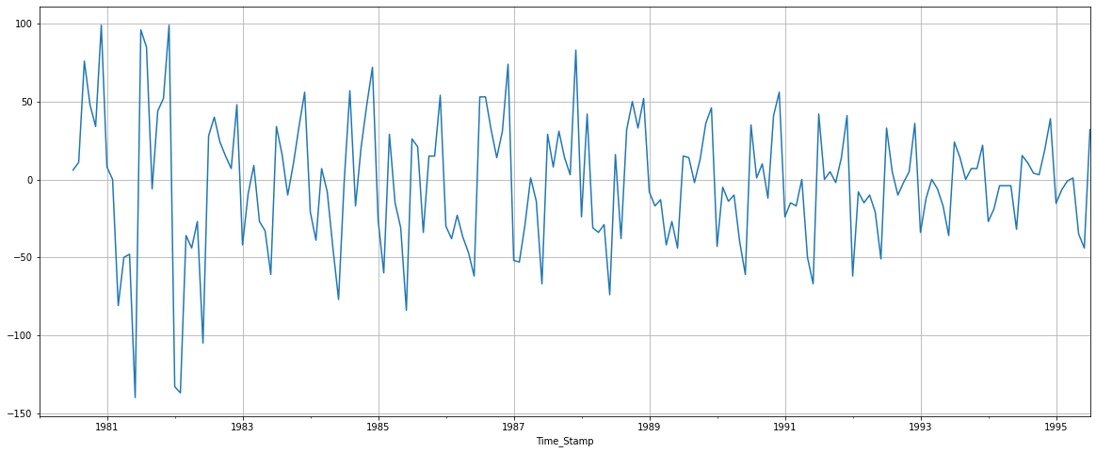

***Figure 7.5(a)***

Now we see that there is almost no trend present in the data. Seasonality is only present in the data.

Let us go ahead and check the stationarity of the above series before fitting the SARIMA model.

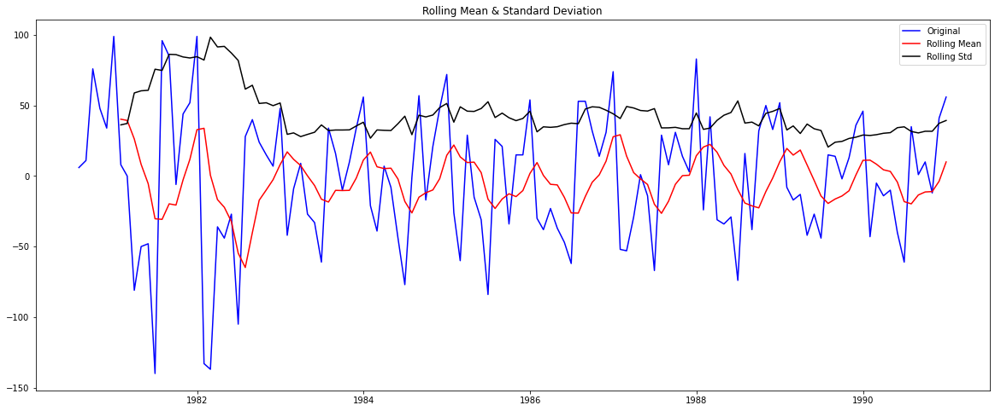

***Figure 7.5(b)***

**Results of Dickey-Fuller Test:**

**Test Statistic -7.442449e+00**

**p-value 5.956534e-11**

**#Lags Used 7.000000e+00**

**Number of Observations Used 1.180000e+02**

**Critical Value (1%) -3.487022e+00**

**Critical Value (5%) -2.886363e+00**

**Critical Value (10%) -2.580009e+00**

**As observed we have a p-value lesser than our alpha 0.05. This explains that our time series is stationary therefore we won’t difference it further.**

Checking the ACF and the PACF plots for the new modified Time Series

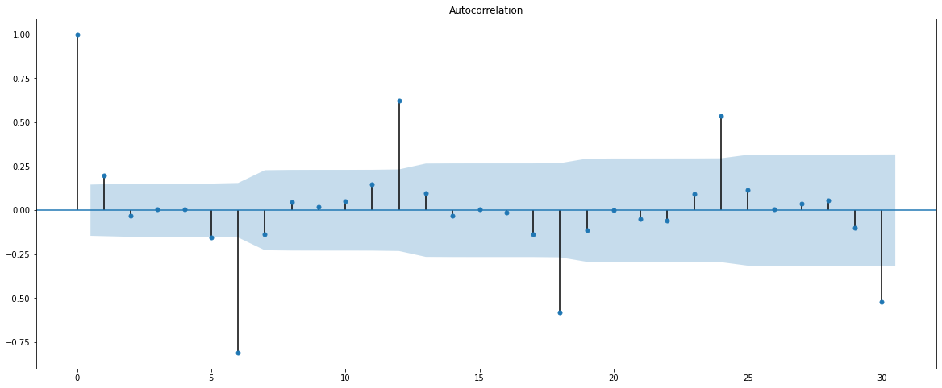

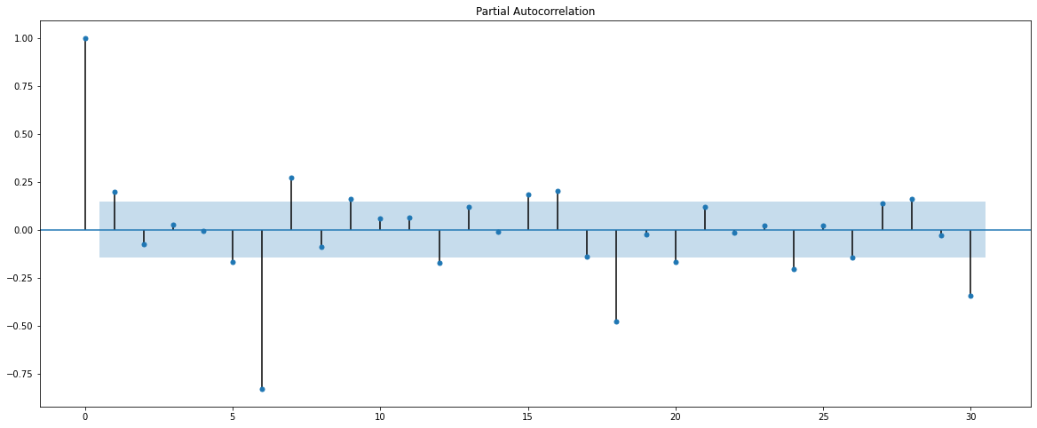

***Figure 7.5(c)***

Here, we have taken alpha=0.05.

We are going to take the seasonal period as 6.

The Auto-Regressive parameter in an SARIMA model is 'P' which comes from the significant lag after which the PACF plot cuts-off to 3 to reduce complexity.

The Moving-Average parameter in an SARIMA model is 'Q' which comes from the significant lag after which the ACF plot cuts-off to 3 to reduce complexity.

Remember to check the ACF and the PACF plots only at multiples of 6 (since 6 is the seasonal period).

Statespace Model Results

=======================================================================================

Dep. Variable: y No. Observations: 132

Model: SARIMAX(3, 1, 2)x(3, 0, 3, 6) Log Likelihood 470.135

Date: Thu, 12 Aug 2021 AIC 964.271

Time: 13:07:01 BIC 996.676

Sample: 0 HQIC 977.415

- 132

Covariance Type: opg

==============================================================================

coef std err z P>|z| [0.025 0.975]

------------------------------------------------------------------------------

ar.L1 0.1695 0.660 0.257 0.797 -1.124 1.463

ar.L2 -0.1613 0.214 -0.755 0.450 -0.580 0.257

ar.L3 -0.0990 0.194 -0.510 0.610 -0.479 0.281

ma.L1 -0.9294 543.081 -0.002 0.999 -1065.348 1063.489

ma.L2 -0.0706 38.142 -0.002 0.999 -74.827 74.686

ar.S.L6 -0.1251 0.128 -0.975 0.329 -0.376 0.126

ar.S.L12 0.7216 0.058 12.347 0.000 0.607 0.836

ar.S.L18 0.0361 0.120 0.301 0.764 -0.199 0.271

ma.S.L6 0.1218 0.207 0.587 0.557 -0.285 0.528

ma.S.L12 -0.2746 0.127 -2.170 0.030 -0.523 -0.027

ma.S.L18 0.0773 0.159 0.487 0.626 -0.234 0.388

sigma2 287.4563 1.56e+05 0.002 0.999 -3.06e+05 3.06e+05

===================================================================================

Ljung-Box (Q): 27.85 Jarque-Bera (JB): 4.79

Prob(Q): 0.93 Prob(JB): 0.09

Heteroskedasticity (H): 0.82 Skew: -0.06

Prob(H) (two-sided): 0.54 Kurtosis: 4.02

Diagnostic Plot

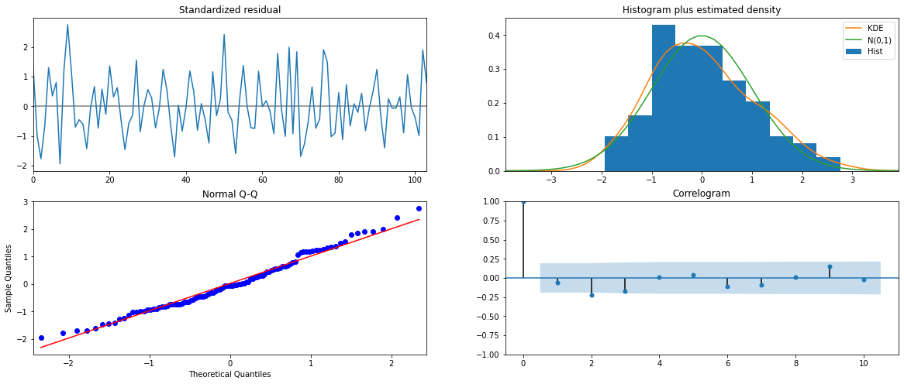

***Figure 7.5(d)***

From the model diagnostics plot, we can see that all the individual diagnostics plots almost follow the theoretical numbers and thus we cannot develop any pattern from these plots.

## Predict on the Test Set using this model and evaluate the model.

DATA SUMMARY

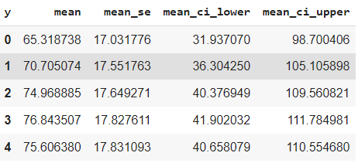

* The RMSE value for ARIMA (3,1,2) is 29.93440417797009
* Seasonality = 12

We see that there is a little trend and seasonality. So, now we take a seasonal differencing and check the series.

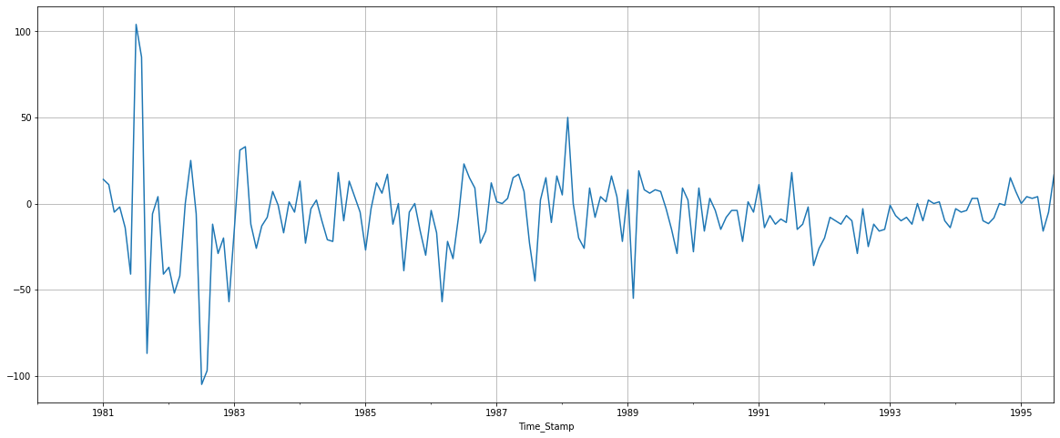

***Figure 7.6(a)***

Now we see that there is almost no trend present in the data. Seasonality is only present in the data.

Let us go ahead and check the stationarity of the above series before fitting the SARIMA model.

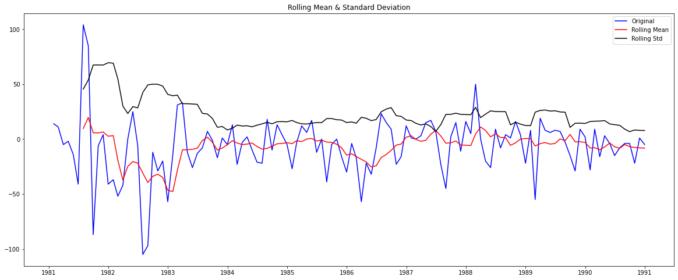

***Figure 7.6(b)***

**Results of Dickey-Fuller Test:**

**Test Statistic -3.619482**

**p-value 0.005399**

**#Lags Used 11.000000**

**Number of Observations Used 108.000000**

**Critical Value (1%) -3.492401**

**Critical Value (5%) -2.888697**

**Critical Value (10%) -2.581255**

**As observed we have a p-value lesser than our alpha 0.05. This explains that our time series is stationary therefore we won’t difference it further.**

Checking the ACF and the PACF plots for the new modified Time Series

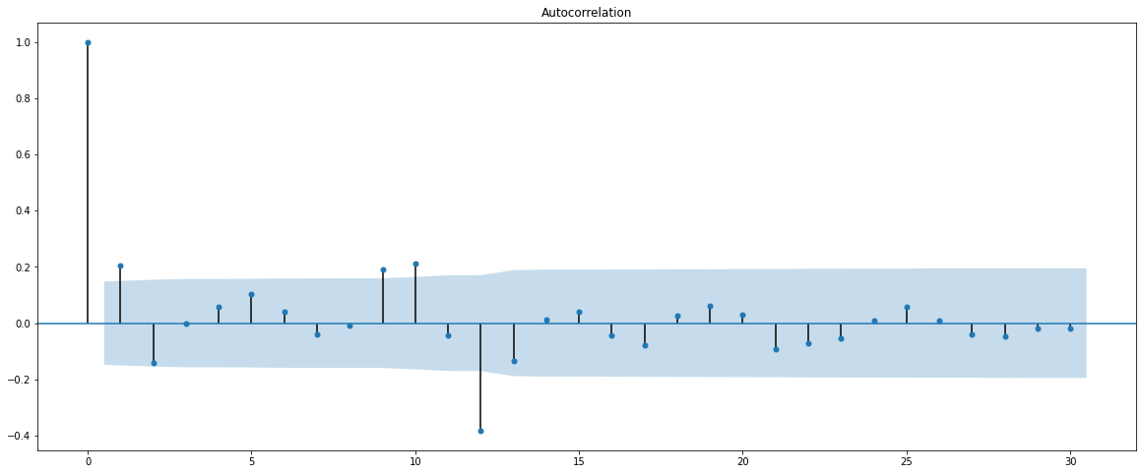

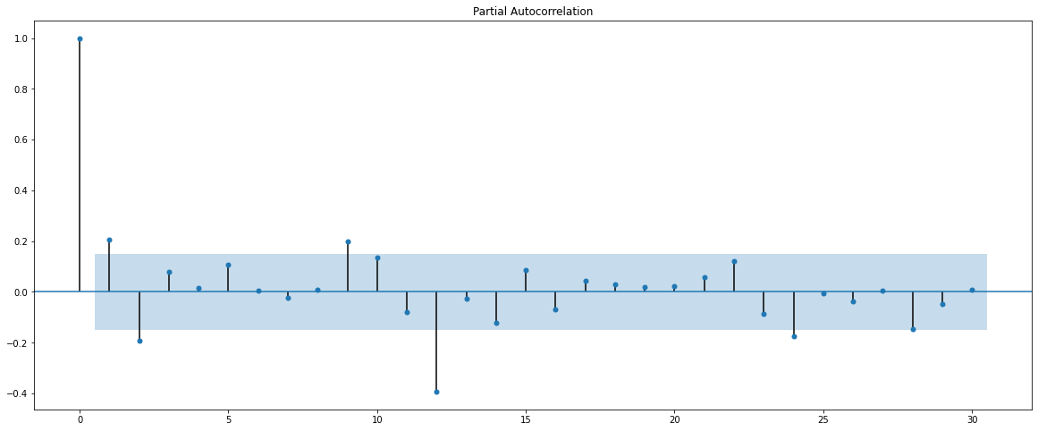

***Figure 7.6(c)***

Here, we have taken alpha=0.05.

We are going to take the seasonal period as 12.

The Auto-Regressive parameter in an SARIMA model is 'P' which comes from the significant lag after which the PACF plot cuts-off to 2.

The Moving-Average parameter in an SARIMA model is 'Q' which comes from the significant lag after which the ACF plot cuts-off to 1.

Remember to check the ACF and the PACF plots only at multiples of 12 (since 12 is the seasonal period).

Statespace Model Results

=======================================================================================

Dep. Variable: y No. Observations: 132

Model: SARIMAX(3, 1, 2)x(2, 0, 1, 12) Log Likelihood 436.164

Date: Thu, 12 Aug 2021 AIC 890.328

Time: 13:33:52 BIC 914.127

Sample: 0 HQIC 899.970

- 132

Covariance Type: opg

==============================================================================

coef std err z P>|z| [0.025 0.975]

------------------------------------------------------------------------------

ar.L1 0.1437 0.780 0.184 0.854 -1.384 1.672

ar.L2 -0.0757 0.159 -0.477 0.634 -0.387 0.235

ar.L3 -0.0817 0.152 -0.537 0.591 -0.380 0.217

ma.L1 -1.0058 550.867 -0.002 0.999 -1080.684 1078.673

ma.L2 0.0058 3.425 0.002 0.999 -6.708 6.719

ar.S.L12 0.3383 0.080 4.214 0.000 0.181 0.496

ar.S.L24 0.2808 0.069 4.090 0.000 0.146 0.415

ma.S.L12 0.1322 0.131 1.010 0.312 -0.124 0.389

sigma2 247.0643 1.36e+05 0.002 0.999 -2.66e+05 2.67e+05

===================================================================================

Ljung-Box (Q): 25.01 Jarque-Bera (JB): 2.71

Prob(Q): 0.97 Prob(JB): 0.26

Heteroskedasticity (H): 0.96 Skew: 0.36

Prob(H) (two-sided): 0.91 Kurtosis: 3.31

Diagnostic Plot

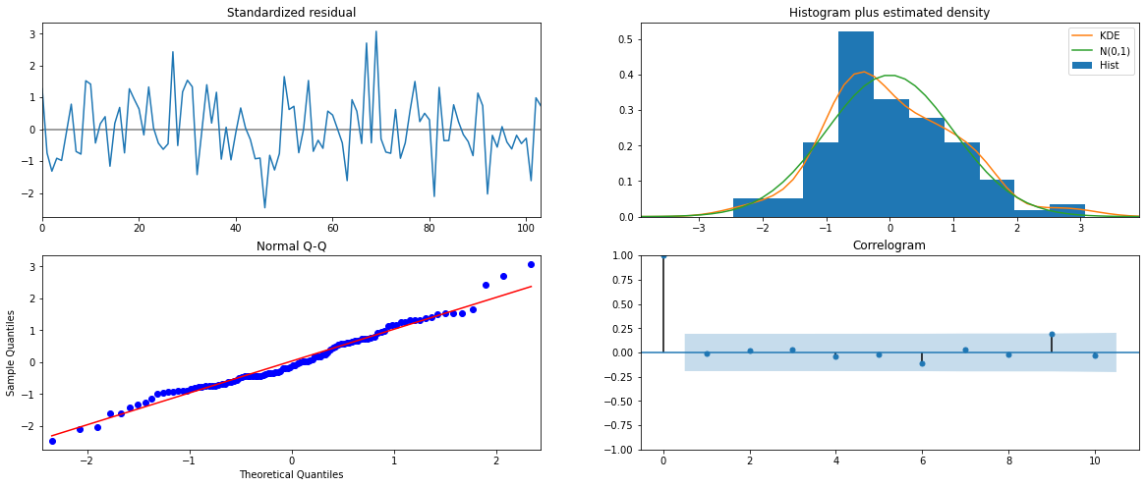

***Figure 7.6(d)***

From the model diagnostics plot, we can see that all the individual diagnostics plots almost follow the theoretical numbers and thus we cannot develop any pattern from these plots.

## Predict on the Test Set using this model and evaluate the model.

DATA SUMMARY

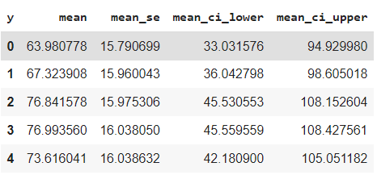

* The RMSE value for ARIMA (3,1,2) is 27.992337075309443

## 8. Build a table (create a data frame) with all the models built along with their corresponding parameters and the respective RMSE values on the test data.

* SPARKLING

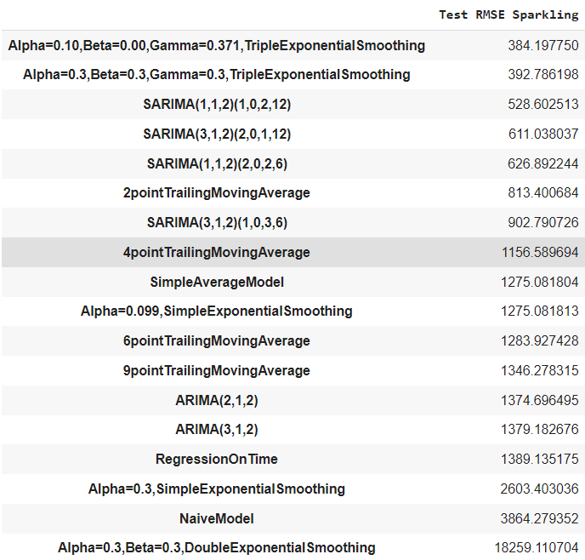

* ROSE

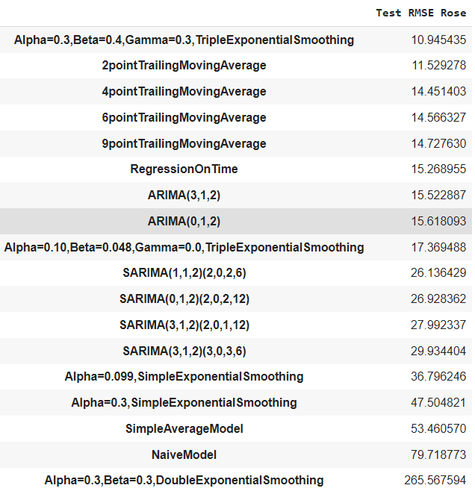

**OBSERVATION**

* For Sparkling Dataset, Triple Exponential Smoothing ( Holt Winter’s) Autofit Model gives us the lowest RMSE value, hence it will be used for building our Optimum Model.
* For Rose Dataset, Triple Exponential Smoothing ( Holt Winter’s) Bestfit Model gives us the lowest RMSE value where alpha=0.3,beta=0.4 and gamma=0.3 hence it will be used for building our Optimum Model.

## 9. Based on the model-building exercise, build the most optimum model(s) on the complete data and predict 12 months into the future with appropriate confidence intervals/bands.

* SPARKLING

Full Data model Summary

ExponentialSmoothing Model Results

================================================================================

Dep. Variable: endog No. Observations: 187

Model: ExponentialSmoothing SSE 22523264.581

Optimized: True AIC 2219.704

Trend: Additive BIC 2271.402

Seasonal: Multiplicative AICC 2223.775

Seasonal Periods: 12 Date: Thu, 12 Aug 2021

Box-Cox: False Time: 14:12:53

Box-Cox Coeff.: None

=================================================================================

coeff code optimized

---------------------------------------------------------------------------------

smoothing_level 0.0681476 alpha True

smoothing_slope 0.0681476 beta True

smoothing_seasonal 0.2568278 gamma True

initial_level 1580.0005 l.0 True

initial_slope 0.000000 b.0 True

initial_seasons.0 1.0476792 s.0 True

initial_seasons.1 1.0068122 s.1 True

initial_seasons.2 1.2620726 s.2 True

initial_seasons.3 1.1703427 s.3 True

initial_seasons.4 0.9727799 s.4 True

initial_seasons.5 0.9526434 s.5 True

initial_seasons.6 1.2620336 s.6 True

initial_seasons.7 1.5960288 s.7 True

initial_seasons.8 1.3169898 s.8 True

initial_seasons.9 1.7611764 s.9 True

initial_seasons.10 2.6440116 s.10 True

initial_seasons.11 3.4137902 s.11 True

---------------------------------------------------------------------------------

/usr/local/lib/python3.7/dist-packages/statsmodels/tsa/holtwinters.py:712: ConvergenceWarning: Optimization failed to converge. Check mle_retvals.

ConvergenceWarning)

FORECASTING AND PREDICTING 12 Months into the future.

Top 5 rows of Predicted values

1995-08-31 1949.155797

1995-09-30 2344.802057

1995-10-31 3180.835470

1995-11-30 3937.976866

1995-12-31 5991.077374

Freq: M, dtype: float64

* RMSE of the Full Model is 347.0522513114097

Calculating the 95% confidence bands for better plotting.

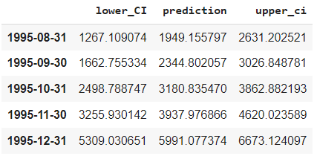

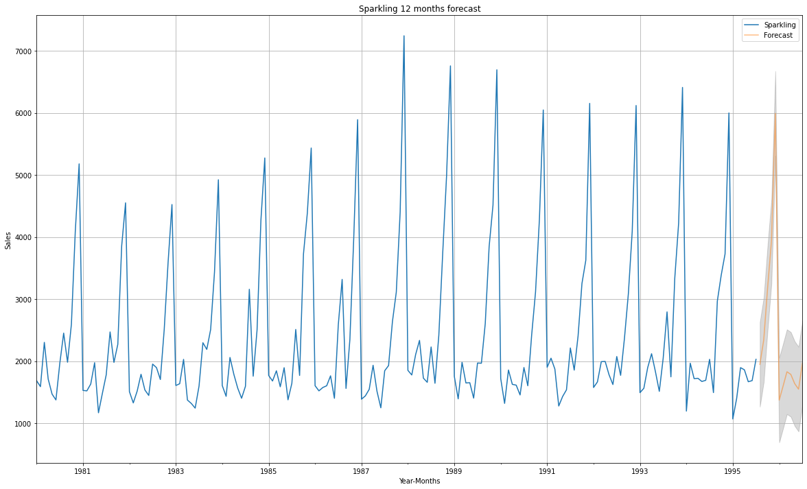

***Figure 9(a)***

* In the plot, the Orange region is our 12 months forecasted value and the shaded region surrounding are the confidence intervals which explains how much variation can be accepted for 95% accuracy of our forecasted values.
* ROSE

Full Data model Summary

ExponentialSmoothing Model Results

================================================================================

Dep. Variable: endog No. Observations: 187

Model: ExponentialSmoothing SSE 110117.712

Optimized: True AIC 1224.723

Trend: Additive BIC 1276.420

Seasonal: Multiplicative AICC 1228.794

Seasonal Periods: 12 Date: Thu, 12 Aug 2021

Box-Cox: False Time: 15:23:46

Box-Cox Coeff.: None

=================================================================================

coeff code optimized

---------------------------------------------------------------------------------

smoothing_level 0.3000000 alpha False

smoothing_slope 0.4000000 beta False

smoothing_seasonal 0.3000000 gamma False

initial_level 64.000000 l.0 True

initial_slope 0.1527778 b.0 True

initial_seasons.0 1.7500000 s.0 True

initial_seasons.1 1.8437500 s.1 True

initial_seasons.2 2.0156250 s.2 True

initial_seasons.3 1.5468750 s.3 True

initial_seasons.4 1.8125000 s.4 True

initial_seasons.5 2.6250000 s.5 True

initial_seasons.6 1.8437500 s.6 True

initial_seasons.7 2.0156250 s.7 True

initial_seasons.8 3.2031250 s.8 True

initial_seasons.9 2.2968750 s.9 True

initial_seasons.10 2.3437500 s.10 True

initial_seasons.11 4.1718750 s.11 True

FORECASTING AND PREDICTING 12 Months into the future.

Top 5 rows of Predicted values

1995-08-31 40.074648

1995-09-30 39.245730

1995-10-31 41.312369

1995-11-30 48.067469

1995-12-31 68.735454

Freq: M, dtype: float64

* RMSE of the Full Model is 24.266535961104537

Calculating the 95% confidence bands for better plotting.

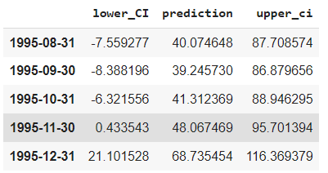

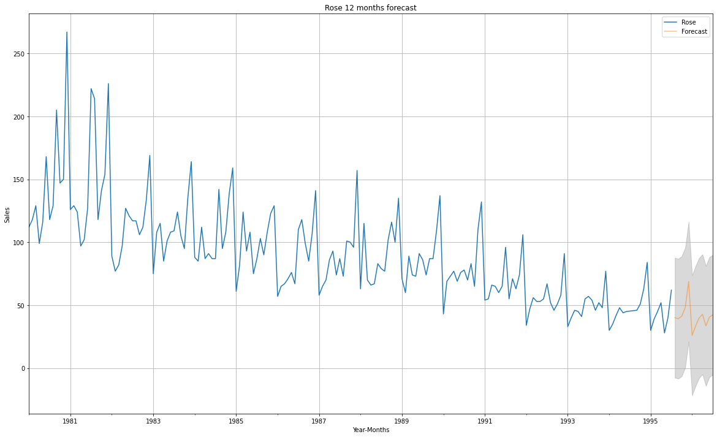

***Figure 9(b)***

* In the plot, the Orange region is our 12 months forecasted value and the shaded region surrounding are the confidence intervals which explains how much variation can be accepted for 95% accuracy of our forecasted values.

**10. Comment on the model thus built and report your findings and suggest the measures that the company should be taking for future sales.**

* As an analyst in the ABC Estate Wines, I was tasked to analyse and forecast Wine Sales in the 20th century of the individual datasets provided for Sparkling and Rose wine sales.
* For Sparkling when we analyze the time series, there was an exponential monthly increase in the wine sales however there was little to none yearly trend present in our data which means the year round sales haven’t improved as compared to previous years.
* For Rose when we analyze the time series, there was an exponential monthly increase in the wine sales however there was a downward yearly trend present in our data which means the year round sales have dropped with each year.
* Both the datasets have trend and seasonality present in them explaining that **our data is not stationary** which is the basis of our **Null hypothesis**.
* This trend and seasonality is fixed by differencing our time series once. This makes it safe to conclude that our **time series is now stationary** which is the basis of our **Alternate Hypothesis**.
* This can also be observed from observing the p-value achieved with the value of alpha=0.05. If our test **p-value < alpha(0.05)** our **Null Hypothesis is rejected** stating that time series is **stationary**.
* If our test **p-value > alpha(0.05)** our **Null Hypothesis is accepted** stating that time series is **not stationary**.
* Also, observing the residual pattern from the decomposition it can be observed that multiplicative decomposition is the best way to go.
* The ACF and PACF gives us the order for Moving Average and Auto Regressive model values which explains the significance of variables for our model.
* RMSE value is the value which explains the error present it the predictions of our models and obviously the best model would be one with the lowest RMSE value.
* After building numerous models for both datasets it can be observed that Triple Exponential Smoothing ( Holt Winter’s) Model is the best/optimum performing model for both datasets giving us the best predictions.
* The only Difference being the Autofit TES model gives us the lowest RMSE for Sparkling dataset.
* However, for Rose Dataset we will manually fit the alpha, beta and gamma values for the TES model.

**Measures that the company should be taking for future sales are:**

* More data should be captured on the wine such as consumer age, to better understand what kind of audience to target.
* Brand recognition is important more emphasis for Rose as they have a downward trend, this can be done by smart marketing of their product by increasing wine tasting initiatives as it is the easiest and most efficient way to achieve recognition.
* Decreasing the alcohol content and increasing the organic products used in wine as the society has become a little sceptical and moving towards a healthy lifestyle.
* Fully Utilizing the modern techniques is something that should be used to its full potential for better and fast production.
* Once the wine has gained recognition it’ll be a huge advantage as import/export will bring in more sales for the product.